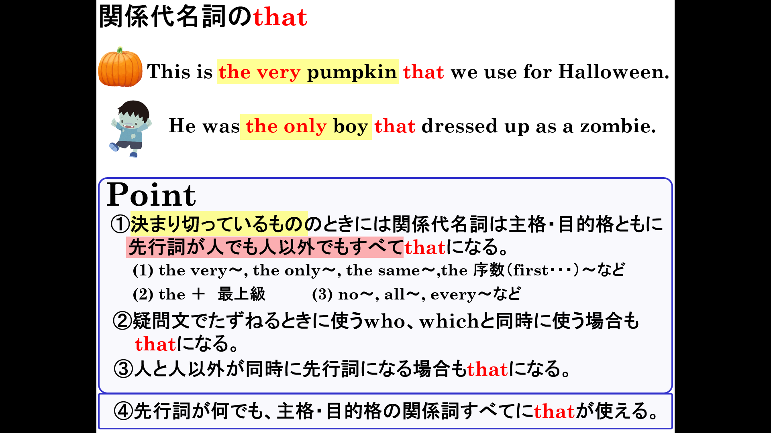

１．関係代名詞を使ってそれぞれの名詞を説明する文章を完成させよう。
(1) Mike saw a spaceship.＋ It came from another planet. マイクは他の星からきた宇宙船を見た。

(2) This is a picture. + My brother took it. これは私の兄が撮った写真です。

(3) The cake was very delicious. + Emi made it. 絵美がつくったケーキはとてもおいしかったです。

(4) The watch is very expensive. + My father bought it. 父が買った時計はとても高価です。

(5) The book is Ken's. + She lost it last week. 先週彼女がなくした本は健のものです。

(6) I saw a man and a cat. + They were on a boat. ボートに乗っている男の人と猫を見た

２. （ ）内の語句を並び替えて、正しい英文を作りましょう。
(1) ( visited / museum / last year / we / that / the / opened / . ) 私たちは昨年オープンした博物館を訪れました。

(2) ( cleaned / used / they / that / the room / the children / had / . ) 彼らは子どもたちが使っていた部屋を掃除しました。

(3) ( the / present / that / he / gave / me / was / a surprise / . ) 彼が私にくれたプレゼントは驚きでした。
(4) ( the / very / that / math / kind / teacher / teaches / is ) 数学を教えている先生はとてもやさしいです。

１．関係代名詞を使ってそれぞれの名詞を説明する文章を完成させよう。
(1) Mike saw a spaceship.＋ It came from another planet. マイクは他の星からきた宇宙船を見た。
Mike saw a spaceship that came from another planet.

(2) This is a picture. + My brother took it. これは私の兄が撮った写真です。
This is a picture that my brother took.

(3) The cake was very delicious. + Emi made it. 絵美がつくったケーキはとてもおいしかったです。
The cake that Emi made was very delicious.

(4) The watch is very expensive. + My father bought it. 父が買った時計はとても高価です。
The watch that my father bought is very expensive.

(5) The book is Ken's. + She lost it last week. 先週彼女がなくした本は健のものです。
The book she lost last week is Ken’s.

(6) I saw a man and a cat. + They were on a boat. ボートに乗っている男の人と猫を見た
I saw a man and a cat that were on a boat.

２. （ ）内の語句を並び替えて、正しい英文を作りましょう。
(1) ( visited / museum / last year / we / that / the / opened / . ) 私たちは昨年オープンした博物館を訪れました。
We visited the museum that opened last year.

(2) ( cleaned / used / they / that / the room / the children / had / . ) 彼らは子どもたちが使っていた部屋を掃除しました。
They cleaned the room that the children had used.

(3) ( the / present / that / he / gave / me / was / a surprise / . ) 彼が私にくれたプレゼントは驚きでした。
The present that he gave me was a surprise.
(4) ( the / very / that / math / kind / teacher / teaches / is ) 数学を教えている先生はとてもやさしいです。
The teacher that teaches math is very kind.

