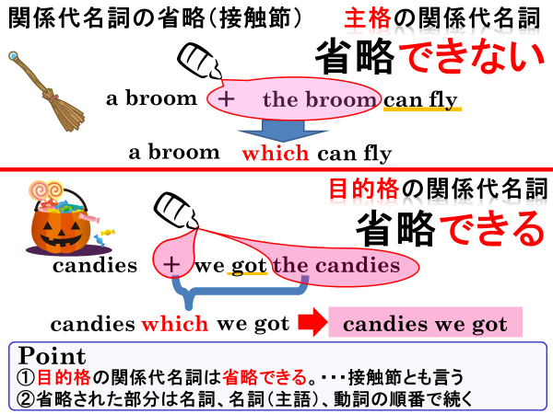
１．次の文の中で関係代名詞を省略できるものが5文あるので、その省略した文を書き、日本語に訳してみよう。
This is the dictionary which he uses every day.
Mr. Mori is a doctor who is very kind to old people.
Mike has lost the toy which his father bought for him.
He found the key which she lost last week.
They want a house that has five bedrooms.
Ms. Sato is a teacher who teaches us English.
Have you seen the book that I put on your desk?
The man that you saw at the store is Takuya's father.
Do you have a cat that is bigger than mine?

(1)
訳（ ）

(2)
訳（ ）

(3)
訳（ ）

(4)
訳（ ）

(5)
訳（ ）

１．次の文の中で関係代名詞を省略できるものが5文あるので、その省略した文を書き、日本語に訳してみよう。
This is the dictionary which he uses every day.
Mr. Mori is a doctor who is very kind to old people.
Mike has lost the toy which his father bought for him.
He found the key which she lost last week.
They want a house that has five bedrooms.
Ms. Sato is a teacher who teaches us English.
Have you seen the book that I put on your desk?
The man that you saw at the store is Takuya's father.
Do you have a cat that is bigger than mine?

(1)
This is dictionary he uses every day.
訳（ これは彼が毎日使っている辞書です。 ）

(2)
Mike has lost the toy his father bought for him.
訳（ マイクは彼の父が彼に買ってあげたオモチャをなくしてしまった。 ）

(3)
He found the key she lost last week.
訳（ 彼は彼女が先週なくしたカギを見つけた。 ）

(4)
Have you seen the book I put on your desk?
訳（ あなたは私があなたの机の上に置いた本を見ましたか？ ）

(5)
The man you saw at the store is Takuya's father.
訳（ その店で見た男の人は卓也の父親だ。 ）

