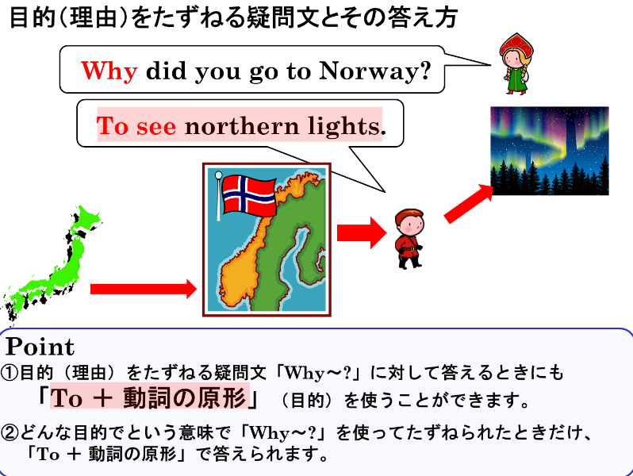
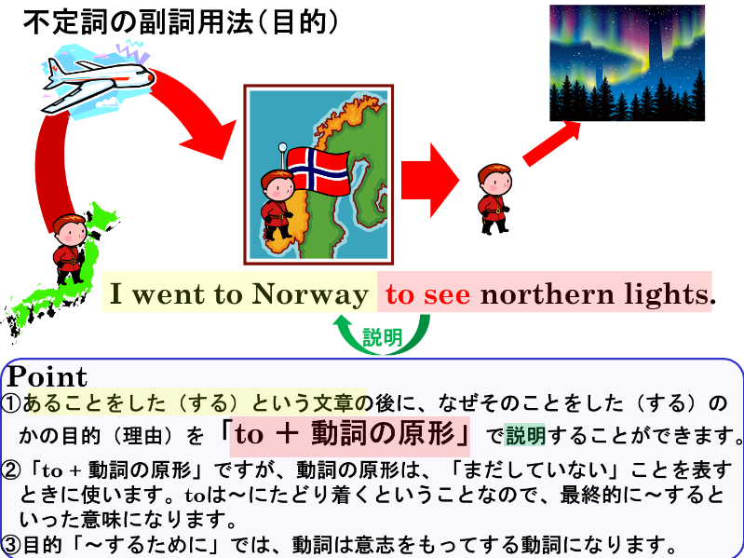

１．AとＢを意味がつながるように組み合わせて5つ文を書き、意味も書きましょう。
B
A
to see her sister
to relax
to pass the exam
to buy some milk
to walk his dog
to be strong
to teach English
to play soccer
to practice tennis
to exchange e-mail

Mary went to the supermarket.
Ken went to the park.
Tom gets up early.
Mr Smith came to Japan.
Ellen will visit France.
Mark uses a computer.
Mrs Brown bought a racket.
Yuko studies hard.
Jiro eats a lot.
Nancy listens to music.

(1)訳（ ）
(2)訳（ ）
(3)訳（ ）
(4)訳（ ）
(5)訳（ ）

２．1で使わなかったものをつかって、Aにある文をWhy～?の疑問文にして、Bにあるもので答えましょう。
(例) Why did Koichi go to a library? - To read books.
(1)

(2)

(3)

(4)

(5)

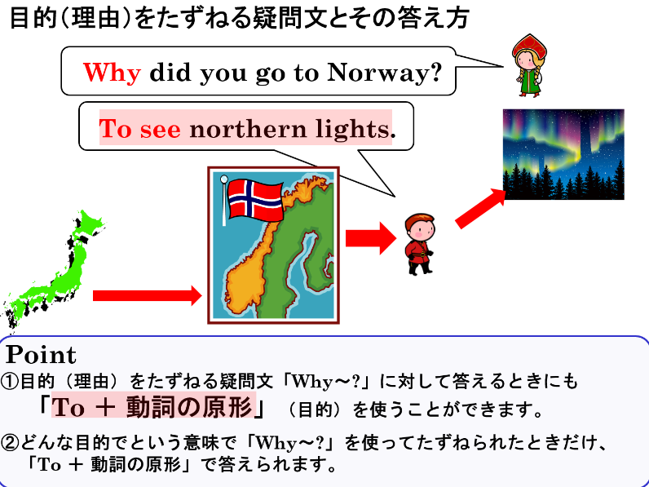

１．AとＢを意味がつながるように組み合わせて5つ文を書き、意味も書きましょう。
B
A
to see her sister
to relax
to pass the exam
to buy some milk
to walk his dog
to be strong
to teach English
to play soccer
to practice tennis
to exchange e-mail

Mary went to the supermarket.
Ken went to the park.
Tom gets up early.
Mr Smith came to Japan.
Ellen will visit France.
Mark uses a computer.
Mrs Brown bought a racket.
Yuko studies hard.
Jiro eats a lot.
Nancy listens to music.

Mary went to the supermarket to buy some milk.（メアリーは牛乳を買うためにスーパーに行った。）
Ken went to the park to play soccer.（健はサッカーをするために公園に行った。）
Tom gets up early to walk his dog.（トムはイヌを散歩するために早起きします。）
Mr Smith came to Japan to teach English.（スミス先生は英語を教えるために日本に来ました。）
Ellen will visit France to see her sister.（エレンは妹（姉）に会うためにフランスを訪れます。）
Mark uses a computer to exchange e-mail.（マークはメール交換をするためにコンピューターを使います。）
Mrs Brown bought a racket to practice tennis.
（ブラウンさんはテニスの練習をするためにラケットを買いました。）
Yuko studies hard to pass the exam.（優子は試験に合格するために一生懸命勉強します。）
Jiro eats a lot to be strong.（次郎は強くなるためにたくさん食べます。）
Nancy listens to music to relax.（ナンシーはリラックスるために音楽を聴きます。）
２．1で使わなかったものをつかって、Aにある文をWhy～?の疑問文にして、Bにあるもので答えましょう。
Why did Mary go to the supermarket? - To buy some milk.
Why did Ken go to the park? - To play soccer.
Why does Tom get up early? - To walk his dog.
Why did Mr Smith come to Japan? - To teach English.
Why will Ellen visit France? - To see her sister.
Why does Mark use a computer? - To exchange e-mail.
Why did Mrs Brown buy a racket? - To practice tennis.
Why does Yuko study hard? - To pass the exam.
Why does Jiro eat a lot? - To be strong.
Why does Nancy listen to music? - To relax.

