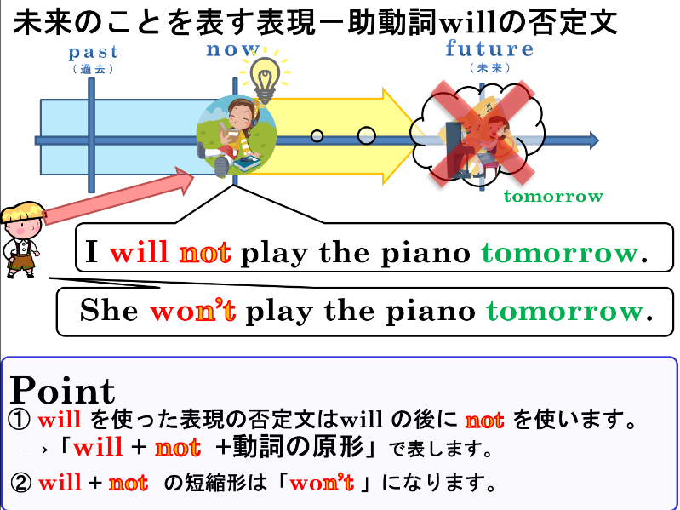
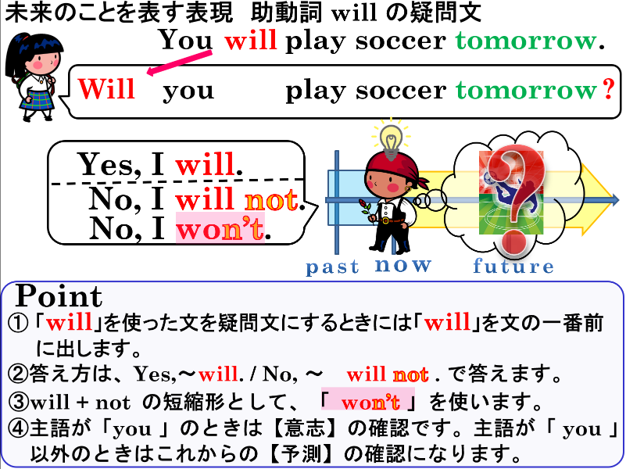

１．（ ）内の適する語に○をつけましょう。
(1) ( Will / Is / Do ) you play baseball tomorrow?
(2) Will Ken ( study / studies / studied ) tomorrow night?
(3) ( Will / Do / Are ) she be at home tonight?
(4) Will it ( rain / rains / rainy ) tomorrow?

２．次の文を疑問文にして、（ ）内の指示で答えましょう。
(1) You will get up at six tomorrow.（Yesで答える）
(2) He will go to America next year.（Noで答える）
(3) She will make breakfast tomorrow.（Yesで答える）
(4) You will be busy tomorrow.（Noで答える）

３．それぞれの会話の質問に合う答え方を書きましょう。
(1) A: Will you come to my party tomorrow?
B: ( ),( )( ). I have club activities.
(2) A: Oh, really? Will Ken come?
B: ( ),( )( ). He loves parties.

３．（ ）内の適する語に○をつけましょう。
(1) I (will not / don’t / is not going) play video games tomorrow.
(2) You ( willn’t / want / won’t ) make dinner tonight.

４．【 】の時間を表す語を使って、未来を表す表現の否定文を書きましょう。
(1) I will play baseball tomorrow.
(2) They will study English this afternoon.
(3) It will be sunny tomorrow.

１．（ ）内の適する語に○をつけましょう。
(1) ( Will / Is / Do ) you play baseball tomorrow?
(2) Will Ken ( study / studies / studied ) tomorrow night?
(3) ( Will / Do / Are ) she be at home tonight?
(4) Will it ( rain / rains / rainy ) tomorrow?

２．次の文を疑問文にして、（ ）内の指示で答えましょう。
(1) You will get up at six tomorrow.（Yesで答える）
Yes, I will.
Will you get up at six tomorrow?
(2) He will go to America next year.（Noで答える）
No, he will not.
Will he go to America next year?
( No, he won’t. )
(3) She will make breakfast tomorrow.（Yesで答える）
Yes, she will.
Will she make breakfast tomorrow?
(4) You will be busy tomorrow.（Noで答える）
(No, I will not.)
No, I won’t.
Will you be busy tomorrow?

３．それぞれの会話の質問に合う答え方を書きましょう。
(1) A: Will you come to my party tomorrow?
B: ( No ),( I )( won’t ). I have club activities.
(2) A: Oh, really? Will Ken come?
B: ( Yes ),( he )( will ). He loves parties.

３．（ ）内の適する語に○をつけましょう。
(1) I (will not / don’t / is not going) play video games tomorrow.
(2) You ( willn’t / want / won’t ) make dinner tonight.

４．【 】の時間を表す語を使って、未来を表す表現の否定文を書きましょう。
(1) I will play baseball tomorrow.
I will not ( won’t ) play baseball tomorrow.
(2) They will study English this afternoon.
They will not ( won’t ) study English this afternoon.
(3) It will be sunny tomorrow.
It will not ( won’t ) be sunny tomorrow.

