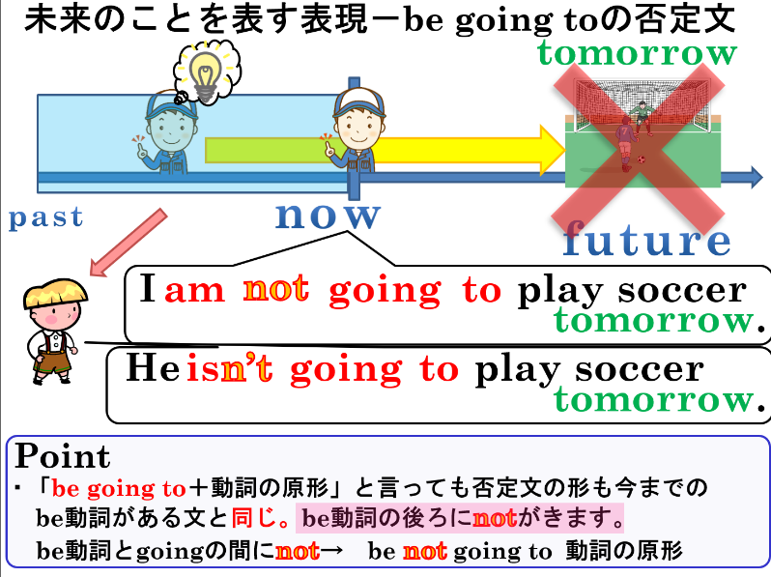
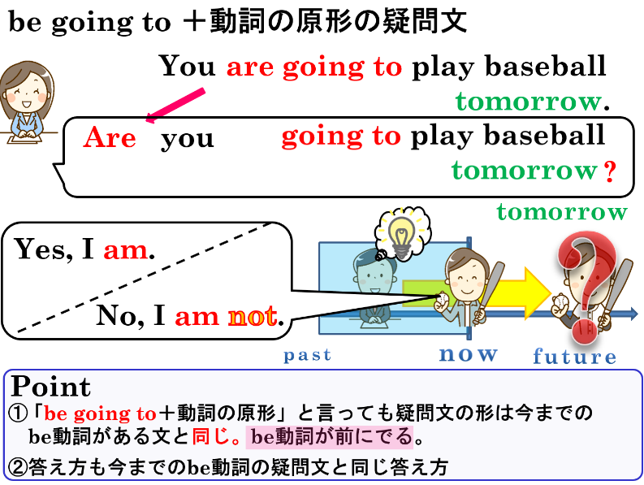

1．次の文を疑問文にして、（ ）内の指示で答えなましょう。
(1) You are going to go to Kyoto next Sunday.（Yesで答える）

(2) He is going to play basketball this afternoon.（Noで答える）

(3) You are going to be busy tonight.（Yesで答える）

(4) They are going to watch TV tonight.（Noで答える）

2．次の文を否定文にしましょう。
(1) I am going to watch TV tonight.

(2)She is going to make breakfast tomorrow.

(3) They are going to go to America next month.

3. 日本文に合うように、( )内の語を並べ替えなさい。
(1) 健は今日の放課後、テニスを練習する予定ですか。( practice / Ken / going / to / is / tennis / after school / ? )

(2) あなたの兄は来月、アメリカへ行く予定ではありません。( not / to / your brother / is / America / going / go / to / next month / . )

(3) 私は明日、暇になりません。( am / free / to / going / I / not / be / tomorrow / . )

(4) あなたは明日、何をする予定ですか。( do / are / going / you / tomorrow / what / to / ? )

1．次の文を疑問文にして、（ ）内の指示で答えなましょう。
(1) You are going to go to Kyoto next Sunday.（Yesで答える）
No, they aren’t.
Are they going to watch TV tonight?
Yes, I am.
Are you going to be busy tonight?
No, he isn’t.
Is he going to play basketball this afternoon?
Yes, I am.
Are you going to go to Kyoto next Sunday?

(2) He is going to play basketball this afternoon.（Noで答える）

(3) You are going to be busy tonight.（Yesで答える）

(4) They are going to watch TV tonight.（Noで答える）

2．次の文を否定文にしましょう。
(1) I am going to watch TV tonight.
I am not going to watch TV tonight.

(2)She is going to make breakfast tomorrow.
She is not going to make breakfast tomorrow.

(3) They are going to go to America next month.
They are not going to go to America next month.

3. 日本文に合うように、( )内の語を並べ替えなさい。
(1) 健は今日の放課後、テニスを練習する予定ですか。( practice / Ken / going / to / is / tennis / after school / ? )
Is Ken going to practice tennis after school?

(2) あなたの兄は来月、アメリカへ行く予定ではありません。( not / to / your brother / is / America / going / go / to / next month / . )
Your brother is not going to go to America next month.

(3) 私は明日、暇になりません。( am / free / to / going / I / not / be / tomorrow / . )
I am not going to be free tomorrow.

(4) あなたは明日、何をする予定ですか。( do / are / going / you / tomorrow / what / to / ? )
What are you going to do tomorrow?

