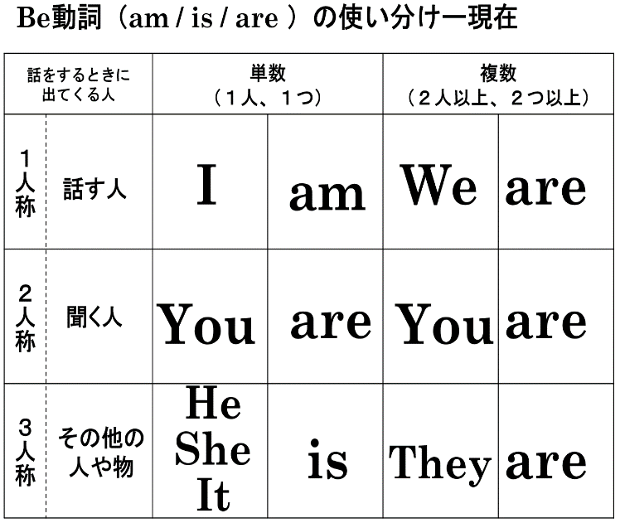
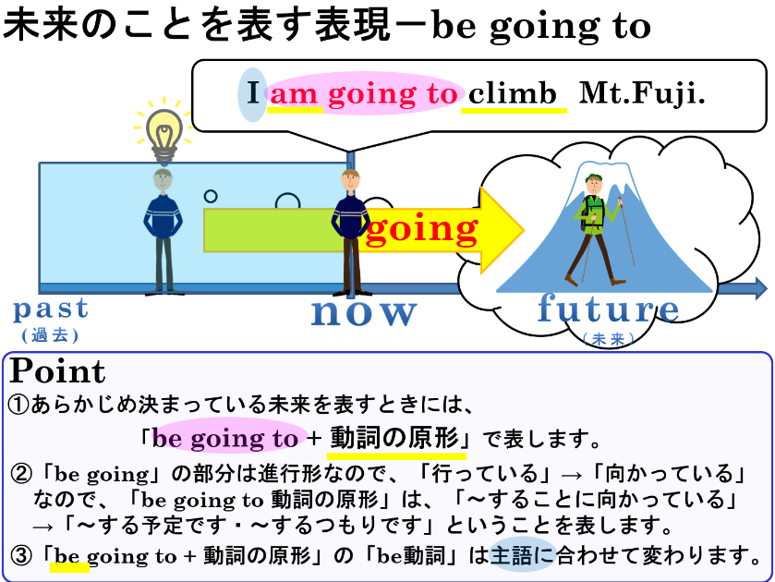

- 「be going to」の「be」は主語によって形が変わります。正しいものを選びましょう。
(1) I ( am / is / are ) going to climb Mt. Fuji.
(2) Ken ( am / is / are ) going to study math tonight.
(3) We ( am / is / are ) going to play soccer tomorrow.
(4) They ( am / is / are ) going to go to America next week.
(5) It ( am / is / are ) going to be rainy tomorrow morning.

２．( ) 内に適切な語を入れて、あらかじめ決まっている予定を表す文にしましょう。
(1) 私は明日、野球をする予定です。
I ( ) ( ) ( ) ( ) baseball tomorrow.
(2) 由美は今日の午後、ギターを弾くつもりです。
Yumi ( ) ( ) ( ) ( ) the guitar this afternoon.
(3) 彼女は明日、6時に起きる予定です。
She ( ) ( ) ( ) ( ) up at six tomorrow.
(4) あなたはこの夏、富士山に登る予定です。
You ( ) ( ) ( ) ( ) Mt. Fuji this summer.

３．【 】内の言葉を最後に付け加えて、全文を書き換えましょう。※動詞の形（三単現のsなど）に注意しよう！
(1) I play baseball. 【tomorrow】

(2) We play soccer.【tomorrow】

(3) He studies math. 【tomorrow night】

(4) My mother makes breakfast.【tomorrow morning】

(5) I am busy. 【tonight】

(6) It is cloudy. 【this afternoon】

- 「be going to」の「be」は主語によって形が変わります。正しいものを選びましょう。
(1) I ( am / is / are ) going to climb Mt. Fuji.
(2) Ken ( am / is / are ) going to study math tonight.
(3) We ( am / is / are ) going to play soccer tomorrow.
(4) They ( am / is / are ) going to go to America next week.
(5) It ( am / is / are ) going to be rainy tomorrow morning.

２．( ) 内に適切な語を入れて、あらかじめ決まっている予定を表す文にしましょう。
(1) 私は明日、野球をする予定です。
I ( am ) ( going ) ( to ) ( play ) baseball tomorrow.
(2) 由美は今日の午後、ギターを弾くつもりです。
Yumi ( is ) ( going ) ( to ) ( play ) the guitar this afternoon.
(3) 彼女は明日、6時に起きる予定です。
She ( is ) ( going ) ( to ) ( get ) up at six tomorrow.
(4) あなたはこの夏、富士山に登る予定です。
You ( are ) ( going ) ( to ) ( climb ) Mt. Fuji this summer.

３．【 】内の言葉を最後に付け加えて、全文を書き換えましょう。※動詞の形（三単現のsなど）に注意しよう！
(1) I play baseball. 【tomorrow】
I am going to play baseball tomorrow.

(2) We play soccer.【tomorrow】
We are going to play soccer tomorrow.

(3) He studies math. 【tomorrow night】
He is going to study math tomorrow night.

(4) My mother makes breakfast.【tomorrow morning】
My mother is going to make breakfast tomorrow morning.

(5) I am busy. 【tonight】
I am going to be busy tonight.

(6) It is cloudy. 【this afternoon】
It is going to be cloudy this afternoon.

