Target: call A B
Class___ No___ Name_______________.
Survey
4人グループで1人２つ調べて、ほかの人に分かったことを英語で伝えよう。
- Many people in Osaka call ( ) Mebachiko.
- Many people in Ehime call ( )Torinokoyoshi.
- Many people in Hokkaido ( ) Sabio.
- Many people in Kagoshima call ( ) Raful.
- Some of people in Nagano call（* ）Hangoroshi.
*food
- Many people in Kansai call Uwabaki ( ).
- Many people in Aichi ( ) Ketta.
- Many people in Kansai call Taiikuzuwari ( ).
=-=-=-=-=-=-=-=-=-=-=-=-=-=-=-=-=-=-=-=-=-=-=-=-
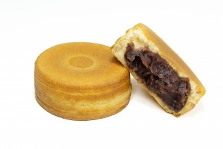
What do you call this?
I call it （ ）.
- Many people in Nagano call it ( ).
- Many people in Ueda call it（ ）.
- Many people in Matsumoto it （ ）.
People named it Imagawayaki in Edo in the 1770s.
Target: call A B
Class___ No___ Name_______________.
Survey
- 4人グループで1人２つ調べて、ほかの人に分かったことを英語で伝えよう。
- Many people in Osaka call ( Monomorai ) Mebachiko.
- Many people in Ehime call ( Mozoshi ) Torinokoyoshi.
- Many people in Hokkaido ( Bansoko ) Sabio.
- Many people in Kagoshima call ( Kokubankeshi ) Raful.
- Some of people in Nagano call（* Ohagi / Botamochi）Hangoroshi.
*food
- Many people in Kansai call Uwabaki ( Uwagutsu ).
- Many people in Aichi ( a bike ) Ketta.
- Many people in Kansai call Taiikuzuwari ( Sankakuzuwari ).
=-=-=-=-=-=-=-=-=-=-=-=-=-=-=-=-=-=-=-=-=-=-=-=-
What do you call this?
I call it （ ）.
- Many people in Nagano call it ( Imagawayaki ).
- Many people in Ueda call it（ Jimanyaki ）.
- Many people in Matsumoto it （ Kaitenyaki ）.
People named it Imagawayaki in Edo in the 1770s.

