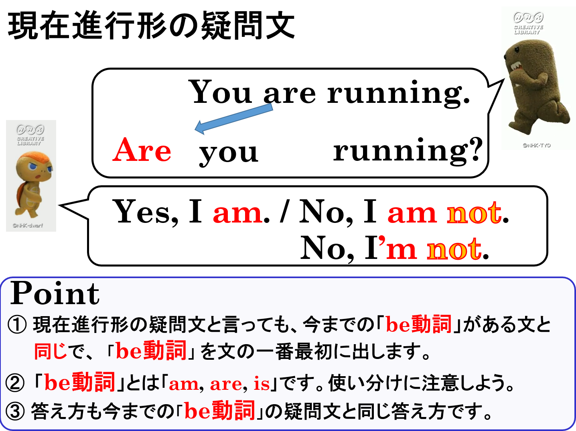

１．次の文を疑問文（たずねる文）にして、（ ）内にあるYesかNoでその答え方も書きましょう。
(1) You are drinking cola. （ Yes ）
(2) You are fishing for wakasagi. （ No ）
(3) Yuki is studying math now. （ Yes ）
(4) Ken is cleaning his room now. （ No ）
(5) He is listening to rock music. （ Yes ）
(6) She is cooking curry. （ No ）
(7) They are playing soccer. （ No ）
(8) *You are having dinner. （ Yes ）*You･･･あなたがた
２．次の疑問文を「～していますか」という疑問文にしましょう。また（ ）内にあるYesかNoでその答え方も書きなさい。
(1) Does he listen to rock music? （ Yes ）

(2) Does she cook curry? （ No ）

１．次の文を疑問文（たずねる文）にして、（ ）内にあるYesかNoでその答え方も書きましょう。
(1) You are drinking cola. （ Yes ）
Are you drinking cola?
Yes, I am.
(2) You are fishing for wakasagi. （ No ）
No, I’m not.(No, I am not.)
Are you fishing for wakasagi?
(3) Yuki is studying math now. （ Yes ）
Is Yuki studying math now?
Yes, she is.
(4) Ken is cleaning his room now. （ No ）
No, he’s not.(No, he isn’t.)
Is Ken cleaning his room now?
(5) He is listening to rock music. （ Yes ）
Is he listening to rock music?
Yes, he is.
(6) She is cooking curry. （ No ）
Is she cooking curry?
No, she’s not.(No, she isn’t.)
(7) They are playing soccer. （ No ）
No, they’re not.(No, they aren’t.)
Are they playing soccer?
(8) *You are having dinner. （ Yes ）*You･･･あなたがた
Yes, we are.
Are you having dinner?
２．次の疑問文を「～していますか」という疑問文にしましょう。また（ ）内にあるYesかNoでその答え方も書きなさい。
(1) Does he listen to rock music? （ Yes ）
Is he listening to rock music?
Yes, he is.

(2) Does she cook curry? （ No ）
No, she’s not.(No, she isn’t.)
Is she cooking curry?

