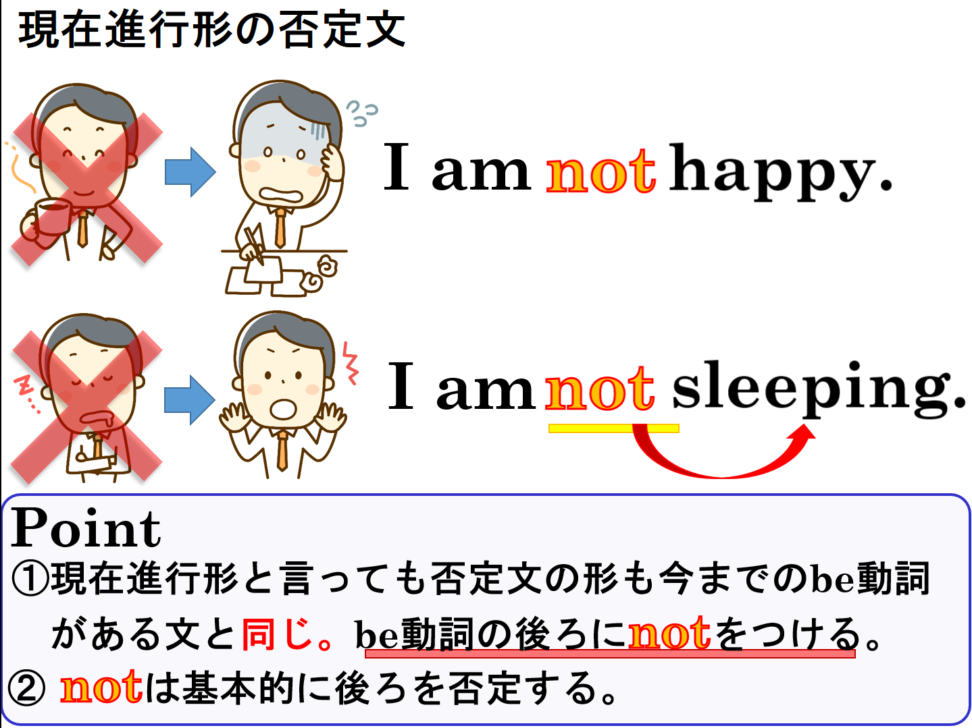

１．次の文を現在進行形の否定文（～していません）にしましょう。
(1) I am playing games.

(2) You are drinking tea.

(3) Ken is having lunch.

(4) Yumi is working.

(5) He is making ramen.

(6) They are eating udon.

(7) We are playing soccer.

２．次の文「～しません」という英文を「～していません」という現在進行形の否定文にしましょう。
(1) He doesn’t make ramen.

(2) She doesn’t do her homework.

１．次の文を現在進行形の否定文（～していません）にしましょう。
(1) I am playing games.
I am not playing games.

(2) You are drinking tea.
You are not (You’re not / aren’t) drinking tea.

(3) Ken is having lunch.
Ken is not (isn’t) having lunch.

(4) Yumi is working.
Yumi is not (isn’t) working.

(5) He is making ramen.
He is not (He’s not / isn’t ) making ramen.

(6) They are eating udon.
They are not (They’re not / aren’t ) eating udon.

(7) We are playing soccer.
We are not (We’re not / aren’t ) playing soccer.

２．次の文「～しません」という英文を「～していません」という現在進行形の否定文にしましょう。
(1) He doesn’t make ramen.
He is not (He’s not / isn’t ) making ramen.

(2) She doesn’t do her homework.
She is not (She’s not / isn’t ) doing her homework.

