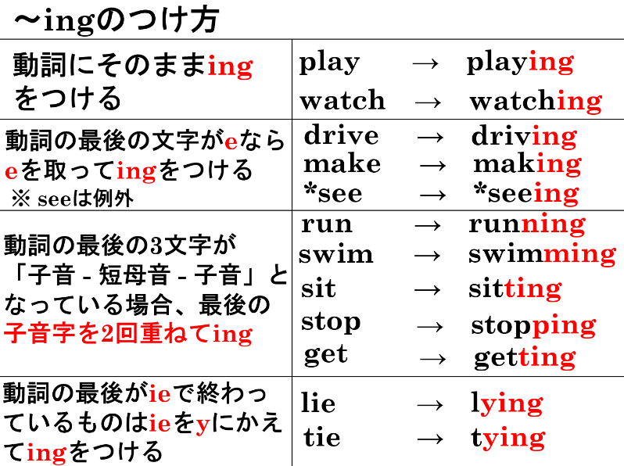
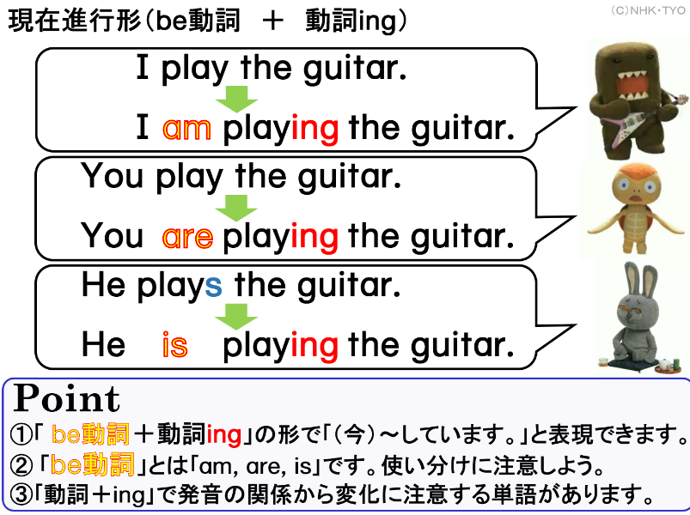

１．次の語をingの形にしましょう。
動詞 | 動詞＋～ing |  | 動詞 | 動詞＋～ing
1 read |  |  | 7 run
2 study |  |  | 8 sleep
3 eat |  |  | 9 swim
4 have |  |  | 10 drive
5 ski |  |  | 11 cook
6 play
２．Be動詞の変化の表を完成させましょう。
 | 単数（1人、1つ） |  | 複数（2人以上、2つ以上）
1人称 | I |  | We
2人称 | You |  | You
3人称 | He, She, It |  | They
３．次の文を現在進行形の文にしましょう。
(1) I play the violin.

(2) You play baseball.
(3) He reads a book.

(4) She studies English.

(5) They have ramen.

(6) We run in the park.

１．次の語をingの形にしましょう。
動詞 | 動詞＋～ing |  | 動詞 | 動詞＋～ing
1 read | reading |  | 7 run | running
2 study | studying |  | 8 sleep | sleeping
3 eat | eating |  | 9 swim | swimming
4 have | having |  | 10 drive | driving
5 ski | skiing |  | 11 cook | cooking
6 play | playing
２．Be動詞の変化の表を完成させましょう。
 | 単数（1人、1つ） |  | 複数（2人以上、2つ以上）
1人称 | I | am | We | are
2人称 | You | are | You | are
3人称 | He, She, It | is | They | are
３．次の文を現在進行形の文にしましょう。
(1) I play the violin.
I am playing the violin.

(2) You play baseball.
You are playing baseball.
(3) He reads a book.
He is reading a book.

(4) She studies English.
She is studying English.

(5) They have ramen.
They are having ramen.

(6) We run in the park.
We are running in the park.

