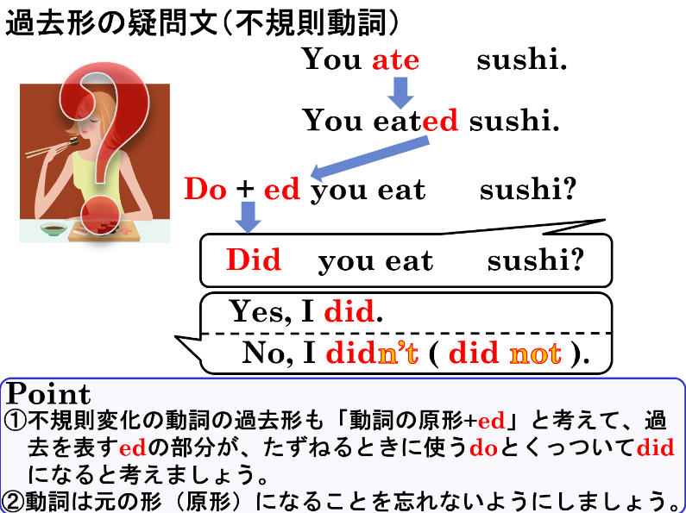
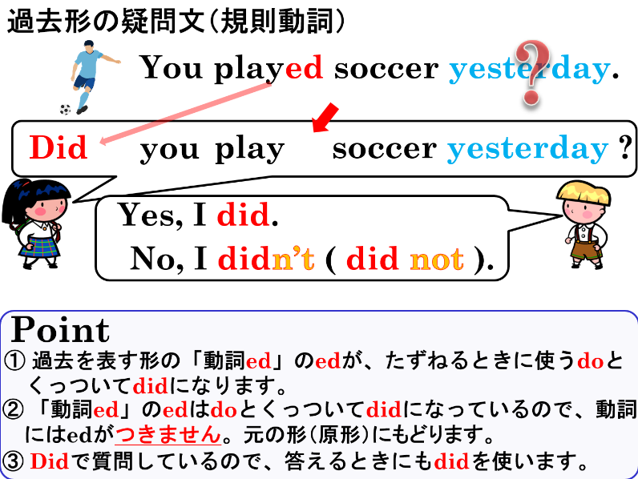

１．それぞれの対話が成り立つように、( ) に適する語を入れなさい。
(1) A: ( Did ) you enjoy the school festival last week?
B: Yes, I did.
(2) A: ( Did ) your sister eat breakfast this morning?
B: No, she didn’t.
(3) A: Did the students run in the park last Sunday?
B: No, ( they ) didn’t.
(4) A: Did you and Yumi clean the classroom yesterday?
B: Yes, ( we ) did.

２．( )内から正しい語を選び、○で囲みなさい。
(1) ( Did / Does ) she ( played / play ) table tennis last Friday?
(2) ( Do / Did ) you ( take / took ) many pictures at the zoo yesterday?
(3) ( Do / Does / Did ) your father ( made / make ) dinner for you last night?
(4) ( Do / Does / Did ) it ( rained / rain ) a lot three days ago?

３．それぞれの文を疑問文（たずねる文）にしましょう。また（ ）にある答え方で答えましょう。
(1) You watched TV yesterday. （Yesで答える）
(2) He played soccer last Sunday. （Noで答える）
(3) They studied science yesterday. （Yesで答える）
(4) You had a dog two years ago. （Noで答える）
(5) She bought a comic book last week. （Yesで答える）
(6) Ken ran to school yesterday. （Noで答える）
(7) Yukiko did her homework last night. （Yesで答える）

１．それぞれの対話が成り立つように、( ) に適する語を入れなさい。
(1) A: ( Did ) you enjoy the school festival last week?
B: Yes, I did.
(2) A: ( Did ) your sister eat breakfast this morning?
B: No, she didn’t.
(3) A: Did the students run in the park last Sunday?
B: No, ( they ) didn’t.
(4) A: Did you and Yumi clean the classroom yesterday?
B: Yes, ( we ) did.

２．( )内から正しい語を選び、○で囲みなさい。
(1) ( Did / Does ) she ( played / play ) table tennis last Friday?
(2) ( Do / Did ) you ( take / took ) many pictures at the zoo yesterday?
(3) ( Do / Does / Did ) your father ( made / make ) dinner for you last night?
(4) ( Do / Does / Did ) it ( rained / rain ) a lot three days ago?

３．それぞれの文を疑問文（たずねる文）にしましょう。また（ ）にある答え方で答えましょう。
(1) You watched TV yesterday. （Yesで答える）
Did you watch TV yesterday?
Yes, I did.
(2) He played soccer last Sunday. （Noで答える）
Did he play soccer last Sunday?
No, he didn’t.
(3) They studied science yesterday. （Yesで答える）
Did they study science yesterday?
Yes, they did.
(4) You had a dog two years ago. （Noで答える）
No, I didn’t.
Did you have a dog two years ago?
(5) She bought a comic book last week. （Yesで答える）
Yes, she did.
Did she buy a comic book last week?
(6) Ken ran to school yesterday. （Noで答える）
No, he didn’t.
Did Ken run to school yesterday?
(7) Yukiko did her homework last night. （Yesで答える）
Did Yukiko do her homework last night?
Yes, she did.

