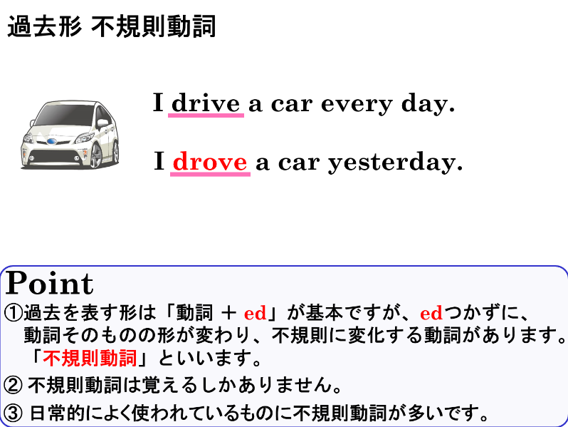
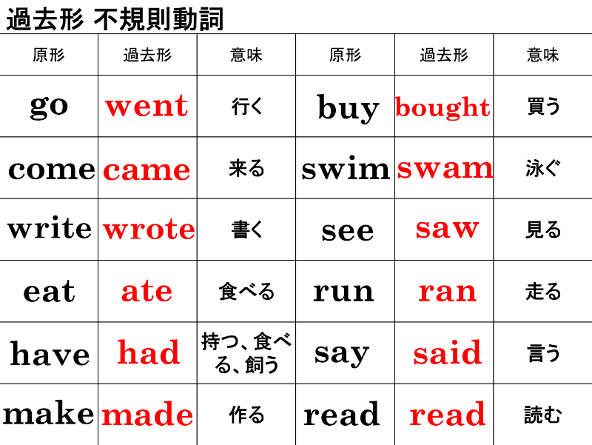

１．次の動詞の意味と過去形を書きましょう。
動詞の原形 | 過去形 | 意味 | 動詞の原形 | 過去形 | 意味
(1) go |  |  | (7) buy
(2) come |  |  | (8) swim
(3) write |  |  | (9) see
(4) eat |  |  | (10) run
(5) have |  |  | (11) say
(6) make |  |  | (12) read

２．次の文の( )内に【 】の語を正しい形にかえて書きましょう。
(1) I ( went ) to the USA last week. 【 go 】
(2) You ( wrote ) a letter last week. 【 write 】
(3) He ( came ) to school yesterday. 【 come 】
(4) She ( made ) cookies last Sunday. 【 make 】
(5) They ( saw ) a movie last Sunday. 【 see 】
(6) We ( said ) hello then. 【 say 】

３．次の文に（ ）内の過去を表すことばを加えて、過去のことを表す文章に書き直しましょう。
(1) I buy a bag. ( last Sunday )
(2) Miki eats sushi. ( yesterday )
(3) Tom has a cat. ( last year )
(4) They swim in the pool. ( last summer )

(5) We see many stars. ( last night )

(6) Ichiro runs to the station. ( this morning )

１．次の動詞の意味と過去形を書きましょう。
動詞の原形 | 過去形 | 意味 | 動詞の原形 | 過去形 | 意味
(1) go | went | 行く | (7) buy | bought | 買う
(2) come | came | 来る | (8) swim | swam | 泳ぐ
(3) write | wrote | 書く | (9) see | saw | 見る
(4) eat | ate | 食べる | (10) run | ran | 走る
(5) have | had | 持つ・食べる・飼う | (11) say | said | 言う
(6) make | made | 作る | (12) read | read | 読む

２．次の文の( )内に【 】の語を正しい形にかえて書きましょう。
(1) I ( went ) to the USA last week. 【 go 】
(2) You ( wrote ) a letter last week. 【 write 】
(3) He ( came ) to school yesterday. 【 come 】
(4) She ( made ) cookies last Sunday. 【 make 】
(5) They ( saw ) a movie last Sunday. 【 see 】
(6) We ( said ) hello then. 【 say 】

３．次の文に（ ）内の過去を表すことばを加えて、過去のことを表す文章に書き直しましょう。
(1) I buy a bag. ( last Sunday )
I bought a bag last Sunday.
(2) Miki eats sushi. ( yesterday )
Miki ate sushi yesterday.
(3) Tom has a cat. ( last year )
Tom had a cat last year.
(4) They swim in the pool. ( last summer )
They swam in the pool last summer.
We saw many stars last night.

(5) We see many stars. ( last night )

(6) Ichiro runs to the station. ( this morning )
Ichiro ran to the station this morning.

