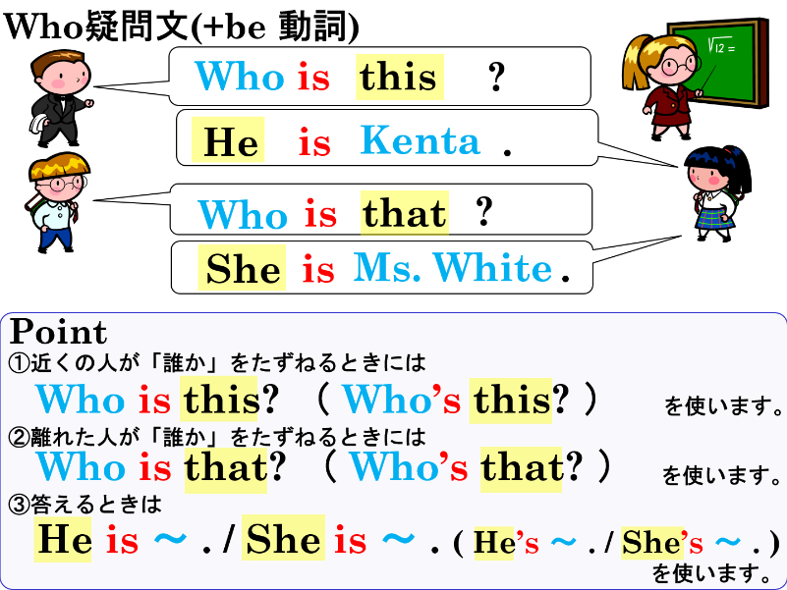
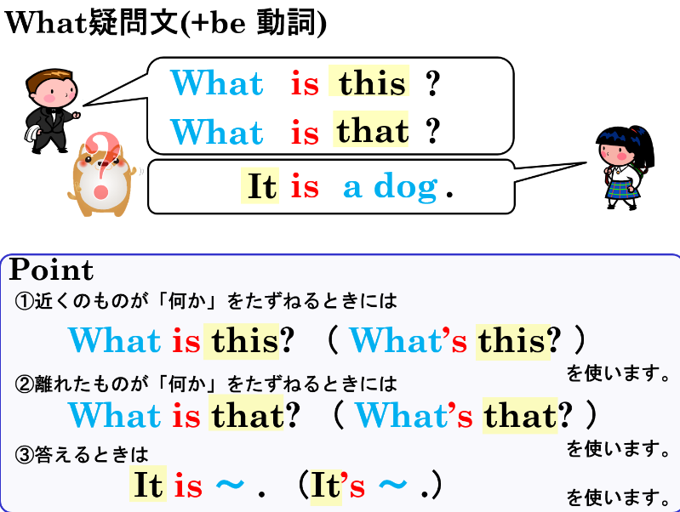

１．次の文の( )内から適切なものを選びましょう。
(1) ( Who / What ) is this? ― It is a smartphone.，
(2) ( Who / What ) is that? ― She is Ms. White. She is my math teacher.
(3) ( Who / What ) is this? ― He is Noah. He is a soccer player.
(4) ( Who / What ) is that? ― It is a bird.

２．質問に対する正しい応答文になるように、( )内から適切なものを選びましょう。
(1) What is this? ― ( It / He / She ) is a stapler.
(2) Who is this? ― ( It / He / She ) is Mia. She takes swimming lessons.
(3) What is that? ― ( It / He / She ) is a cute koala.
(4) Who is that? ― ( It / He / She ) is Kenta. He is my best friend.

３．日本語にあう英文になるように( )内の語句を並べかえて全文を書きましょう。
(1) あなたの一番好きな（お気に入りの）サッカー選手は誰ですか。( your / is / soccer player / who / favorite / ?)

(2) (1)に答えて、私の一番好きなサッカー選手はカオルです。( soccer player / my / is / favorite ) Kaoru.

(3) あれは何ですか。( that / what / is / ? )

(4) (3)に答えて、それは私のペンケースです。( pen case / it / my / is / . )

４．それぞれの日本語に合う英文を書きましょう。
(1) これは何ですか。

(2) あの女性(woman)は誰ですか。

(3) (2)の答えとして、彼女は私の担任の先生( homeroom teacher )です。

１．次の文の( )内から適切なものを選びましょう。
(1) ( Who / What ) is this? ― It is a smartphone.，
(2) ( Who / What ) is that? ― She is Ms. White. She is my math teacher.
(3) ( Who / What ) is this? ― He is Noah. He is a soccer player.
(4) ( Who / What ) is that? ― It is a bird.

２．質問に対する正しい応答文になるように、( )内から適切なものを選びましょう。
(1) What is this? ― ( It / He / She ) is a stapler.
(2) Who is this? ― ( It / He / She ) is Mia. She takes swimming lessons.
(3) What is that? ― ( It / He / She ) is a cute koala.
(4) Who is that? ― ( It / He / She ) is Kenta. He is my best friend.

３．日本語にあう英文になるように( )内の語句を並べかえて全文を書きましょう。
Who is your favorite soccer player?
(1) あなたの一番好きな（お気に入りの）サッカー選手は誰ですか。( your / is / soccer player / who / favorite / ?)

(2) (1)に答えて、私の一番好きなサッカー選手はカオルです。( soccer player / my / is / favorite ) Kaoru.
My favorite soccer player is Kaoru.

(3) あれは何ですか。( that / what / is / ? )
What is that?

(4) (3)に答えて、それは私のペンケースです。( pen case / it / my / is / . )
It is my pen case.

４．それぞれの日本語に合う英文を書きましょう。
What is this? (What’s this?)
(1) これは何ですか。

(2) あの女性(woman)は誰ですか。
Who is that woman?

(3) (2)の答えとして、彼女は私の担任の先生( homeroom teacher )です。
She is my homeroom teacher.

