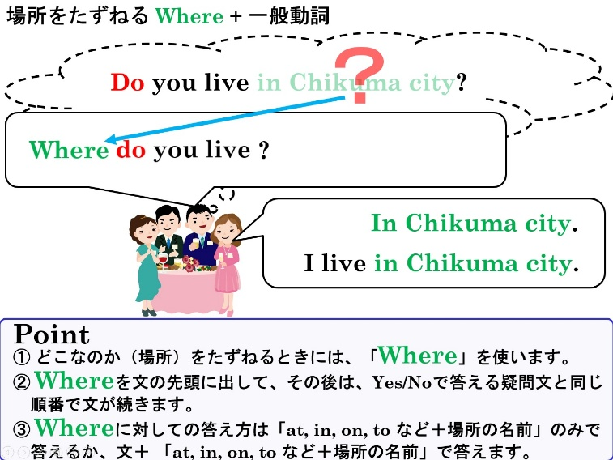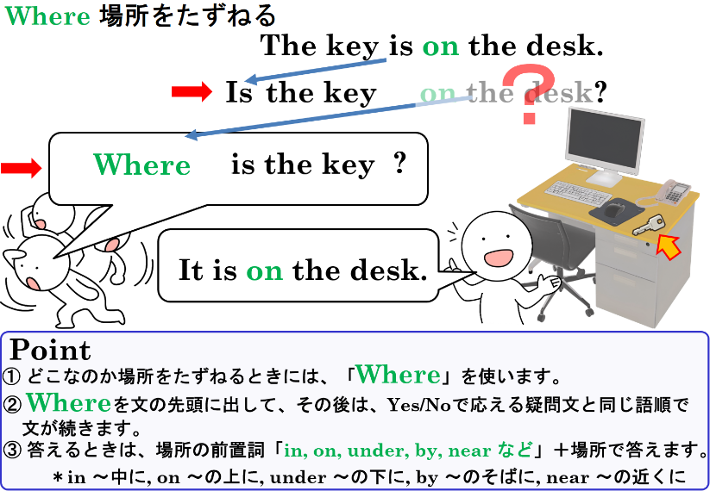

1.　それぞれの日本の意味を表すように、（　　　）に適切な語を書いてみよう。

(1) Your book is ( ) the desk. あなたの本は机の上にあります。

(2) I live ( 　　) the station. 私は駅の近くに住んでいます。

(3) I read a book (　　 ) the library. 私は図書館で本を読みます。

(4) We play tennis ( 　　) the park. 私たちは公園でテニスをします。

2. 次の英文をYes-Noでこたえる疑問文にしよう。

(1) The book is on the desk.

|  |
| --- |
|  |
|  |
|  |

(2) The pen is in the box.

|  |
| --- |
|  |
|  |
|  |

(3) You have lunch at a Chinese restaurant.

|  |
| --- |
|  |
|  |
|  |

(4) You want to go to a movie theater.

|  |
| --- |
|  |
|  |
|  |

(5) We can go to the park in case of a disaster. * in case of a disaster ･･･　災害時に

|  |
| --- |
|  |
|  |
|  |

3. 2の(1)～(5)の英文の下線部分をたずねる疑問文を書こう（2のYes-No疑問文を参考にしよう）。

|  |  |
| --- | --- |
| (1) |  |
|  |
|  |

|  |  |
| --- | --- |
| (2) |  |
|  |
|  |

|  |  |
| --- | --- |
| (3) |  |
|  |
|  |

|  |  |
| --- | --- |
| (4) |  |
|  |
|  |

|  |  |
| --- | --- |
| (5) |  |
|  |
|  |