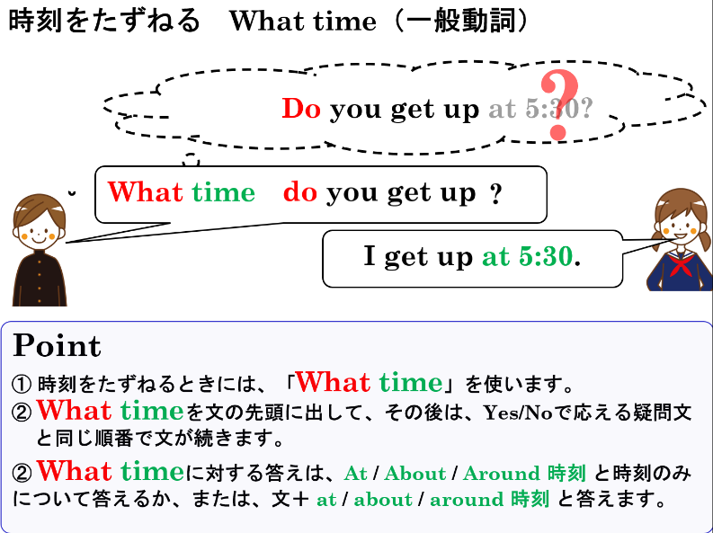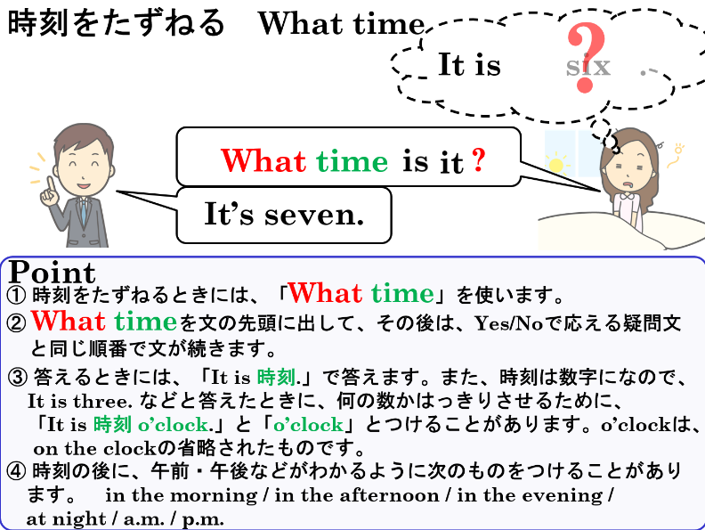

1.　次の英文をYes-Noでこたえる疑問文にしよう。

(1) It is three o’clock.

|  |
| --- |
|  |
|  |
|  |

(2) It’s ten in the morning.

|  |
| --- |
|  |
|  |
|  |

(3) You eat breakfast at 6:30.

|  |
| --- |
|  |
|  |
|  |

(4) You leave home for school at 7:30.

|  |
| --- |
|  |
|  |
|  |

(5) You want to go to bed at 23:00 on Fridays.

|  |
| --- |
|  |
|  |
|  |

(6) You can get up at 6:00.

|  |
| --- |
|  |
|  |
|  |

2. 1の(1)～(6)の英文の下線部分をたずねる疑問文を書こう（1のYes-No疑問文を参考にしよう）。

|  |  |
| --- | --- |
| (1) |  |
|  |
|  |

|  |  |
| --- | --- |
| (2) |  |
|  |
|  |

|  |  |
| --- | --- |
| (3) |  |
|  |
|  |

|  |  |
| --- | --- |
| (4) |  |
|  |
|  |

|  |  |
| --- | --- |
| (5) |  |
|  |
|  |

|  |  |
| --- | --- |
| (6) |  |
|  |
|  |