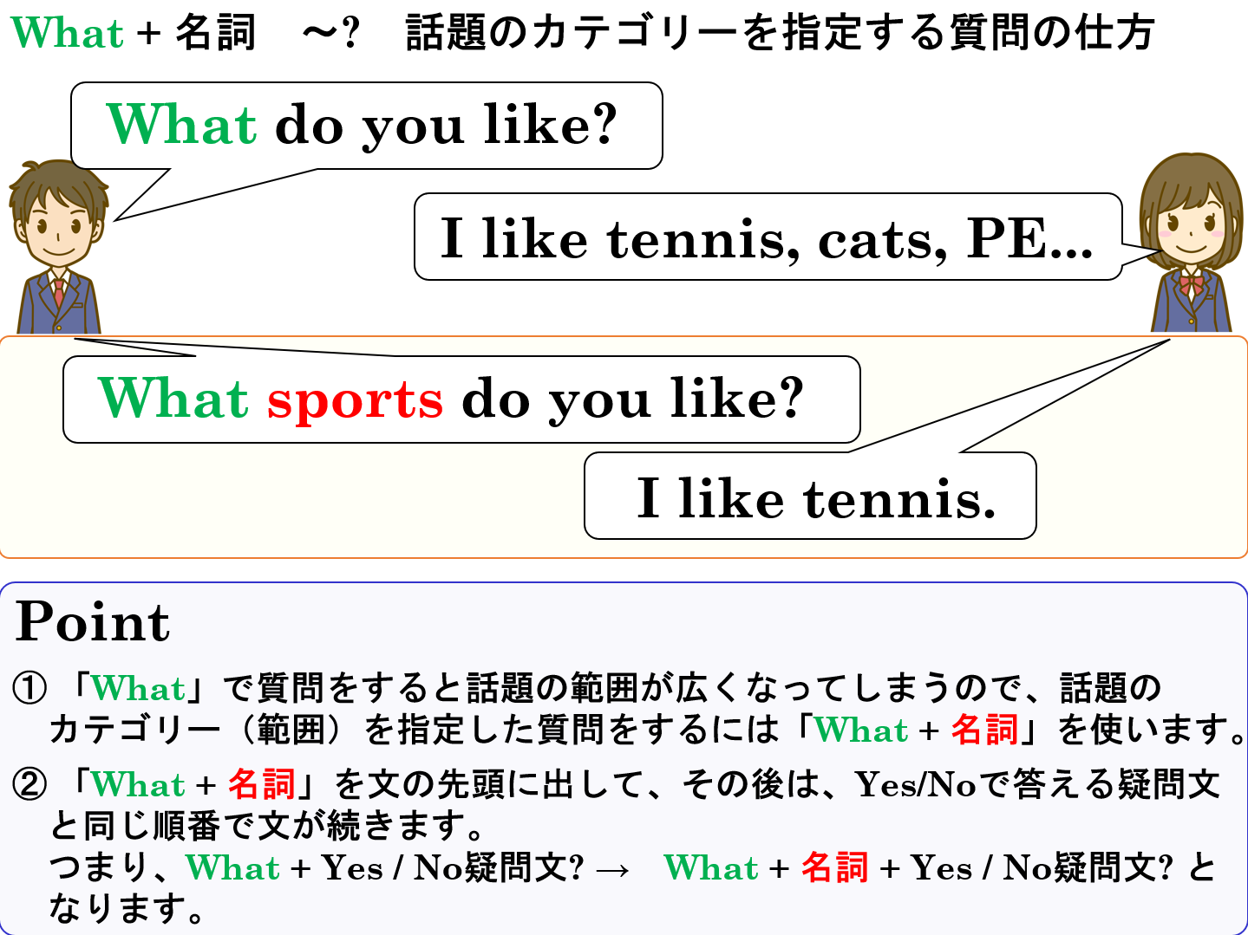

1. 次の英文をYes-Noでこたえる疑問文にしよう。

(1) You like sushi.

|  |
| --- |
|  |
|  |
|  |

(2) You like yellow. *color

|  |
| --- |
|  |
|  |
|  |

(3) You like English. *subject

|  |
| --- |
|  |
|  |
|  |

(4) You want to eat sweet.

|  |
| --- |
|  |
|  |
|  |

(5) You can play tennis. *sport

|  |
| --- |
|  |
|  |
|  |

2. 1の(1)～(5)の英文の下線部分をたずねる疑問文を書こう。（1のYes-No疑問文を参考にしよう。）注(2),(3),(5)

|  |  |
| --- | --- |
| (1) |  |
|  |
|  |

|  |  |
| --- | --- |
| (2) |  |
|  |
|  |

|  |  |
| --- | --- |
| (3) |  |
|  |
|  |

|  |  |
| --- | --- |
| (4) |  |
|  |
|  |

|  |  |
| --- | --- |
| (5) |  |
|  |
|  |



1. 次の英文をYes-Noでこたえる疑問文にしよう。

(1) You like sushi.

Do you like sushi?

|  |
| --- |
|  |
|  |
|  |

(2) You like yellow. *color

Do you like yellow?

|  |
| --- |
|  |
|  |
|  |

(3) You like English. *subject

|  |
| --- |
|  |
| Do you like English? |
|  |

(4) You want to eat sweet.

Do you want to eat sweet?

|  |
| --- |
|  |
|  |
|  |

(5) You can play tennis. *sport

Can you play tennis?

|  |
| --- |
|  |
|  |
|  |

2. 1の(1)～(5)の英文の下線部分をたずねる疑問文を書こう。（1のYes-No疑問文を参考にしよう。）注(2),(3),(5)

|  |  |
| --- | --- |
| (1) |  |
| What sushi do you like? |
| What color do you like? |

|  |  |
| --- | --- |
| (2) |  |
|  |
| What subject do you like? |

|  |  |
| --- | --- |
| (3) |  |
|  |
| What sweet do you want to eat? |

What sport can you play?

|  |  |
| --- | --- |
| (4) |  |
|  |
|  |

|  |  |
| --- | --- |
| (5) |  |
|  |
|  |