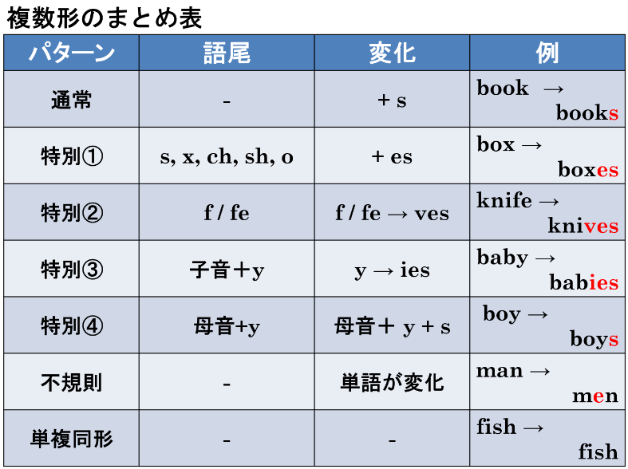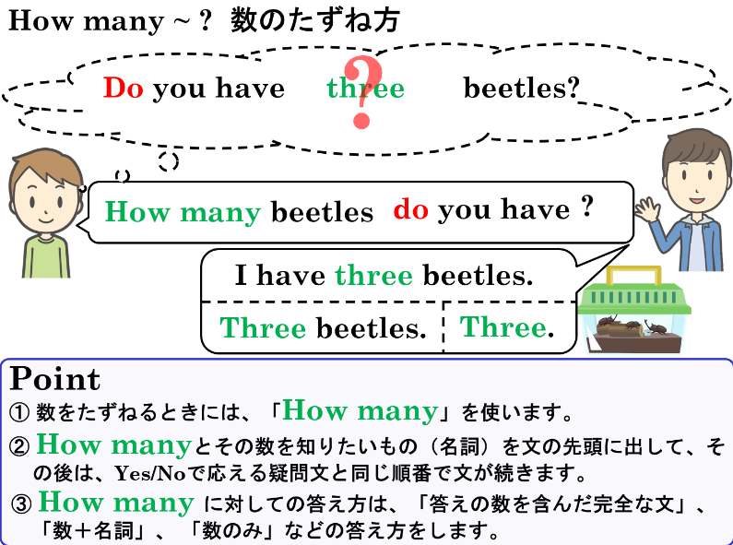

1.　それぞれの名詞の複数形を書いてみよう

|  |  |  |  |  |  |
| --- | --- | --- | --- | --- | --- |
| 例 | pen | pens | (4) | box |  |
| (1) | bag |  | (5) | city |  |
| (2) | boy |  | (6) | story |  |
| (3) | watch |  | (7) | man |  |

2. 次の英文をYes-Noでこたえる疑問文にしよう。

(1) You have three cats.

|  |
| --- |
|  |
|  |
|  |

(2) You have five dogs.

|  |
| --- |
|  |
|  |
|  |

(3) You have eight pencils.

|  |
| --- |
|  |
|  |
|  |

(4) You can see five monkeys.

|  |
| --- |
|  |
|  |
|  |

(5) Four books are in your backpack.

|  |
| --- |
|  |
|  |
|  |

3. 2の(1)～(5)の英文の下線部分をたずねる疑問文を書こう（2のYes-No疑問文を参考にしよう）。

|  |  |
| --- | --- |
| (1) |  |
|  |
|  |

|  |  |
| --- | --- |
| (2) |  |
|  |
|  |

|  |  |
| --- | --- |
| (3) |  |
|  |
|  |

|  |  |
| --- | --- |
| (4) |  |
|  |
|  |

|  |  |
| --- | --- |
| (5) |  |
|  |
|  |



1.　それぞれの名詞の複数形を書いてみよう

|  |  |  |  |  |  |
| --- | --- | --- | --- | --- | --- |
| 例 | pen | pens | (4) | box | boxes |
| (1) | bag | bags | (5) | city | cities |
| (2) | boy | boys | (6) | story | stories |
| (3) | watch | watches | (7) | man | men |

2. 次の英文をYes-Noでこたえる疑問文にしよう。

(1) You have three cats.

|  |
| --- |
|  |
|  |
| Do you have three cats? |

(2) You have five dogs.

Do you have five dogs?

|  |
| --- |
|  |
|  |
|  |

(3) You have eight pencils.

Do you have eight pencils?

|  |
| --- |
|  |
|  |
|  |

(4) You can see five monkeys.

Can you see five monkeys?

|  |
| --- |
|  |
|  |
|  |

(5) Four books are in your backpack.

Are four books in your backpack?

|  |
| --- |
|  |
|  |
|  |

3. 2の(1)～(5)の英文の下線部分をたずねる疑問文を書こう（2のYes-No疑問文を参考にしよう）。

How many cats do you have?

|  |  |
| --- | --- |
| (1) |  |
|  |
| How many dogs do you have? |

|  |  |
| --- | --- |
| (2) |  |
|  |
| How many pencils do you have? |

|  |  |
| --- | --- |
| (3) |  |
|  |
|  |

|  |  |
| --- | --- |
| (4) |  |
|  |
| How many books are in your backpack?  How many monkeys can you see? |

|  |  |
| --- | --- |
| (5) |  |
|  |
|  |

Are four books in your backpack?

Can you see five monkeys?

Do you have eight pencils?

Do you have five dogs?