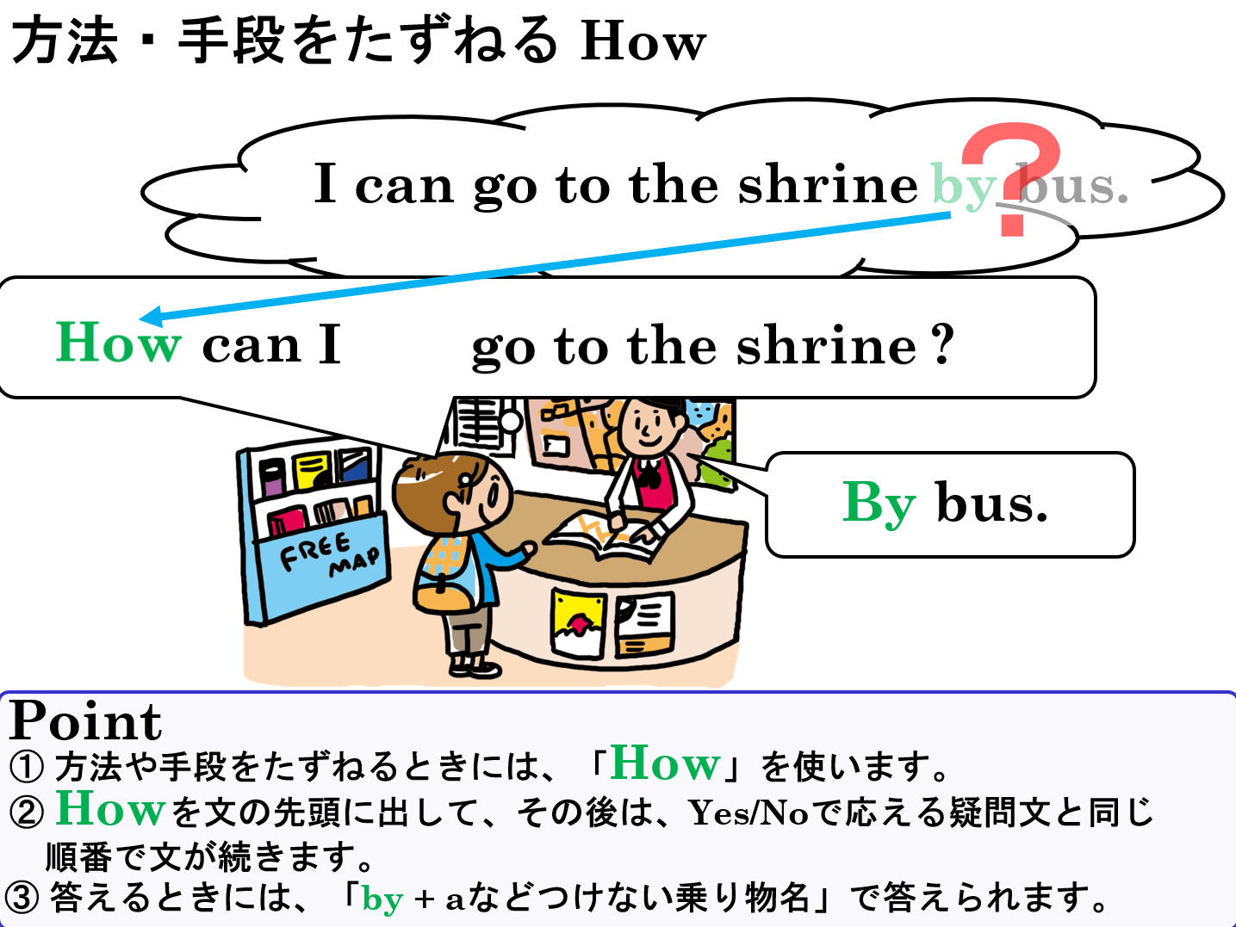

1．次の英文をYes-Noでこたえる疑問文にしよう。

(1) I can go to the station by bus.

|  |
| --- |
|  |
|  |
|  |

(2) I can go to the airport by train.

|  |
| --- |
|  |
|  |
|  |

(3) You come to school by bike.

|  |
| --- |
|  |
|  |
|  |

(4) You come here by car.

|  |
| --- |
|  |
|  |
|  |

(5) We can go to the hot spring by taxi.

|  |
| --- |
|  |
|  |
|  |

(6) We can go to the shrine on foot.

|  |
| --- |
|  |
|  |
|  |

2．1の疑問文を変えて交通手段をたずねる英文とその答えを2語の英語でこたえる英語を書こう。

|  |  |  |
| --- | --- | --- |
| (1) |  |  |
|  |  |
|  |  |

|  |  |  |
| --- | --- | --- |
| (2) |  |  |
|  |  |
|  |  |

|  |  |  |
| --- | --- | --- |
| (3) |  |  |
|  |  |
|  |  |

|  |  |  |
| --- | --- | --- |
| (4) |  |  |
|  |  |
|  |  |

|  |  |  |
| --- | --- | --- |
| (5) |  |  |
|  |  |
|  |  |

|  |  |  |
| --- | --- | --- |
| (6) |  |  |
|  |  |
|  |  |