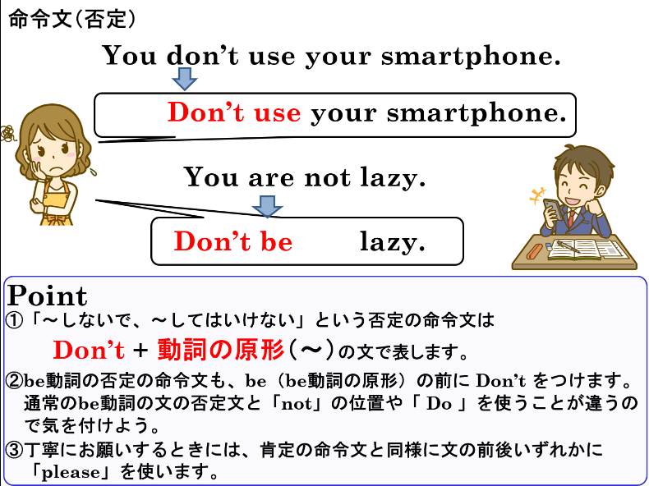
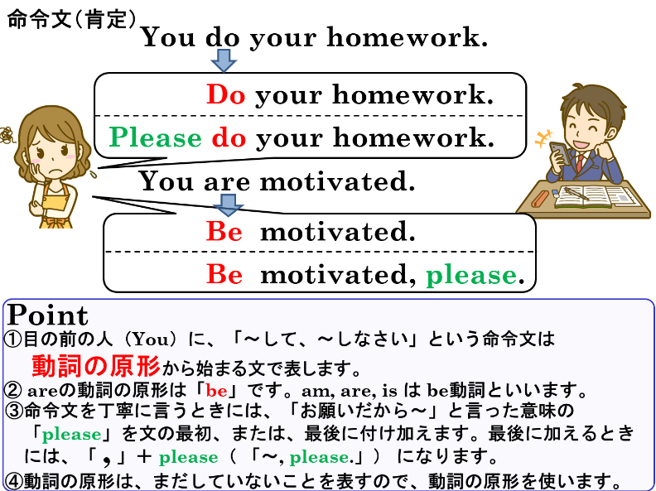


1. 次のそれぞれの文を命令文にしましょう。
(1) You wake up.


(2) You study English hard.


(3) You speak English. （pleaseも加えよう）



(4) You are careful.


(5) You are a good boy.

2. 次のそれぞれの文を否定の命令文にしましょう。

(1) You cry.

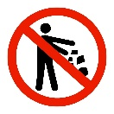
(2) You throw trash.


(3) You take pictures. （pleaseも加えよう）


(4) You are afraid.

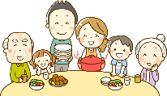
(5) You are shy.

1. 次のそれぞれの文を命令文にしましょう。
(1) You wake up.
Wake up.

(2) You study English hard.
Study English hard, please. ? Please study English. hard.

(3) You speak English. （pleaseも加えよう）
Speak English.

(4) You are careful.
Be careful.

(5) You are a good boy.
Be a good boy.

2. 次のそれぞれの文を否定の命令文にしましょう。
(1) You cry.
Don’t cry.

(2) You throw trash.
Don’t throw trash.

(3) You take pictures. （pleaseも加えよう）
Don’t take picture.

(4) You are afraid.
Don’t be afraid.

(5) You are shy.
Don’t be shy.

