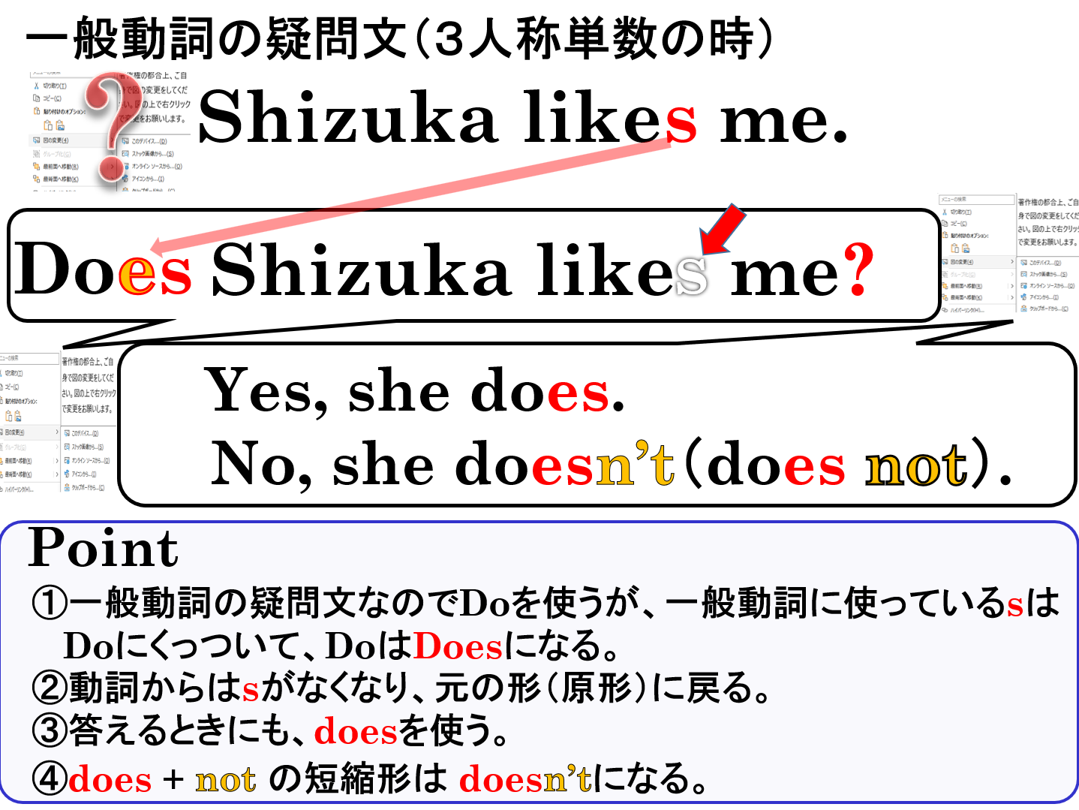

１．それぞれのア～ウの中から正しい英文を選びましょう。
(1) ア Does Dorami likes melon-pan?  イ Does Dorami like melon-pan?  ウ Do Dorami likes melon-pan? | (2) ア Do she plays the violin?  イ Does she plays the violin?  ウ Does she play the violin?

２．質問に対して、適切な答えをそれぞれのア～ウの中から選びましょう。
(1) Does she like dancing?  ア Yes, she do.  イ Yes, she dos.  ウ Yes, she does. | (2) Do Ken and Yumi play tennis?  ア No, he doesn’t.  イ No, they don’t.  ウ No, they doesn’t.

３．次の文を疑問文（たずねる文）にして、（ ）内にあるYesかNoでその答え方も書きましょう。
(1) Ken plays baseball. （ Yes ）

(2) Doraemon likes mice. （ No ）

(3) He eats dorayaki. （ Yes ）

(4) Emi studies English. （ No ）

(5) He lives in Canada. （ Yes ）

(6) She teaches math.（ No ）

(7) Shizuka likes sweet potatoes. （ Yes ）

(8) He has a Time Machine. （ Yes ）

１．それぞれのア～ウの中から正しい英文を選びましょう。
(1) ア Does Dorami likes melon-pan?  イ Does Dorami like melon-pan?  ウ Do Dorami likes melon-pan? | (2) ア Do she plays the violin?  イ Does she plays the violin?  ウ Does she play the violin?

２．質問に対して、適切な答えをそれぞれのア～ウの中から選びましょう。
(1) Does she like dancing?  ア Yes, she do.  イ Yes, she dos.  ウ Yes, she does. | (2) Do Ken and Yumi play tennis?  ア No, he doesn’t.  イ No, they don’t.  ウ No, they doesn’t.

３．次の文を疑問文（たずねる文）にして、（ ）内にあるYesかNoでその答え方も書きましょう。
(1) Ken plays baseball. （ Yes ）
Yes, he does.
Does Ken play baseball?

(2) Doraemon likes mice. （ No ）
No, he doesn’t(does not).
Does Doraemon like mice?

(3) He eats dorayaki. （ Yes ）
Yes, he does.
Does he eat dorayaki?

(4) Emi studies English. （ No ）
No, she doesn’t(does not).
Does Emi study English?

(5) He lives in Canada. （ Yes ）
Does he live in Canada?
Yes, he does.

(6) She teaches math.（ No ）
No, she doesn’t(does not).
Does she teach math?

(7) Shizuka likes sweet potatoes. （ Yes ）
Yes, she does.
Does Shizuka like sweet potatoes?

(8) He has a Time Machine. （ Yes ）
Does he have a Time Machine?
Yes, he does.

