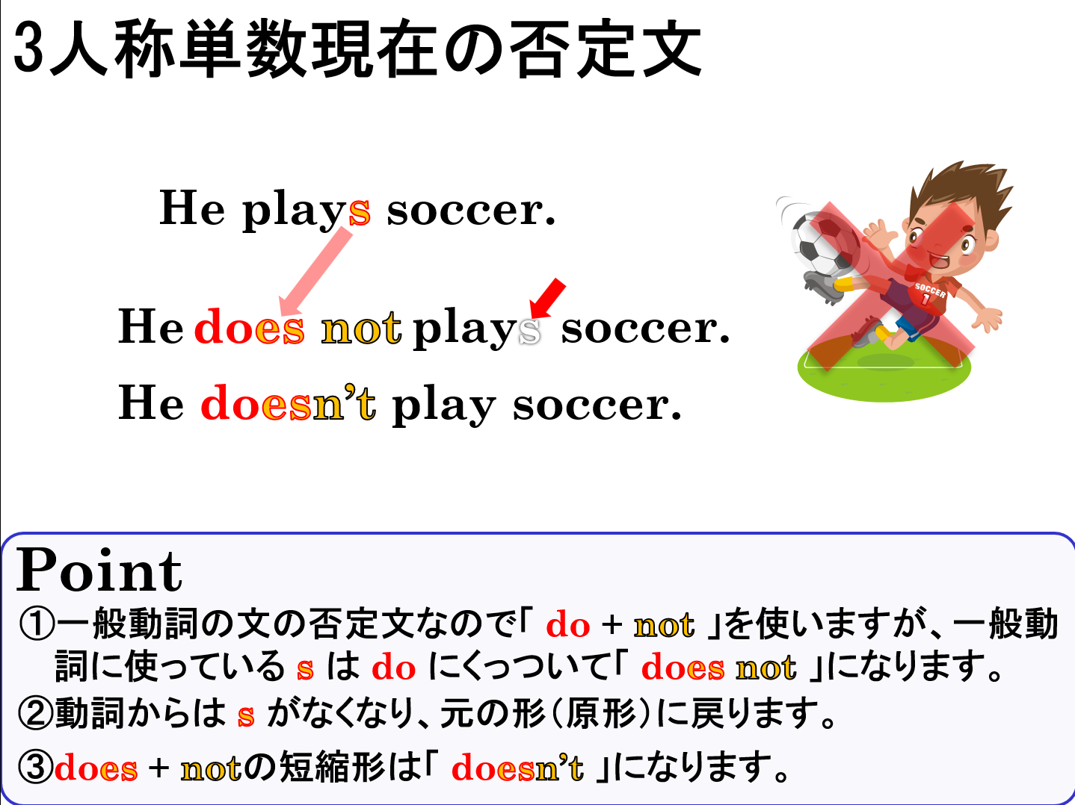

１．次の英文を「～しません。」という否定を表す表現に書き換えましょう。
(1) Taro plays basketball.
(2) Mika likes softball.
(3) My father takes a bath after dinner.
(4) He does his homework.

２．（ ）内の語を並べ替えて、正しい否定文を作りましょう。
(1) ( play / doesn’t / the piano / he )
(2) ( doesn’t / she / at seven / get up )

３．それぞれの英文には誤りがあります。正しい英文にしましょう。
(1) He doesn’t eats breakfast at six.
(2) My sister don’t goes to bed at eleven.

４．次の会話を読んで、（ ）に入る最も自然な英文を選びましょう。
(1) A: Does Ken’s mother watch TV before dinner?  B: No, she doesn’t. → ( )  ア She doesn’t watch TV before dinner.  イ She doesn't watches TV before dinner.  ウ She don’t watch TV before dinner. | (2) A: Does Takashi leave home at seven?  B: No, he doesn’t. → ( )  ア He doesn’t leaves home at seven.  イ He don’t leave home at seven.  ウ He doesn’t leave home at seven.

１．次の英文を「～しません。」という否定を表す表現に書き換えましょう。
(1) Taro plays basketball.
Taro doesn’t ( does not ) play basketball.
(2) Mika likes softball.
Mika doesn’t ( does not ) like softball.
(3) My father takes a bath after dinner.
My father doesn’t ( does not ) take a bath after dinner.
(4) He does his homework.
He doesn’t ( does not ) do his homework.

２．（ ）内の語を並べ替えて、正しい否定文を作りましょう。
(1) ( play / doesn’t / the piano / he )
He doesn’t play the piano.
(2) ( doesn’t / she / at seven / get up )
She doesn’t get up at seven.

３．それぞれの英文には誤りがあります。正しい英文にしましょう。
(1) He doesn’t eats breakfast at six.
He doesn’t eat breakfast at six.
(2) My sister don’t goes to bed at eleven.
My sister doesn’t go to bed at eleven.

４．次の会話を読んで、（ ）に入る最も自然な英文を選びましょう。
(1) A: Does Ken’s mother watch TV before dinner?  B: No, she doesn’t. → ( )  ア She doesn’t watch TV before dinner.  イ She doesn’t watches TV before dinner.  ウ She don’t watch TV before dinner. | (2) A: Does Takashi leave home at seven?  B: No, he doesn’t. → ( )  ア He doesn’t leaves home at seven.  イ He don’t leave home at seven.  ウ He doesn’t leave home at seven.

