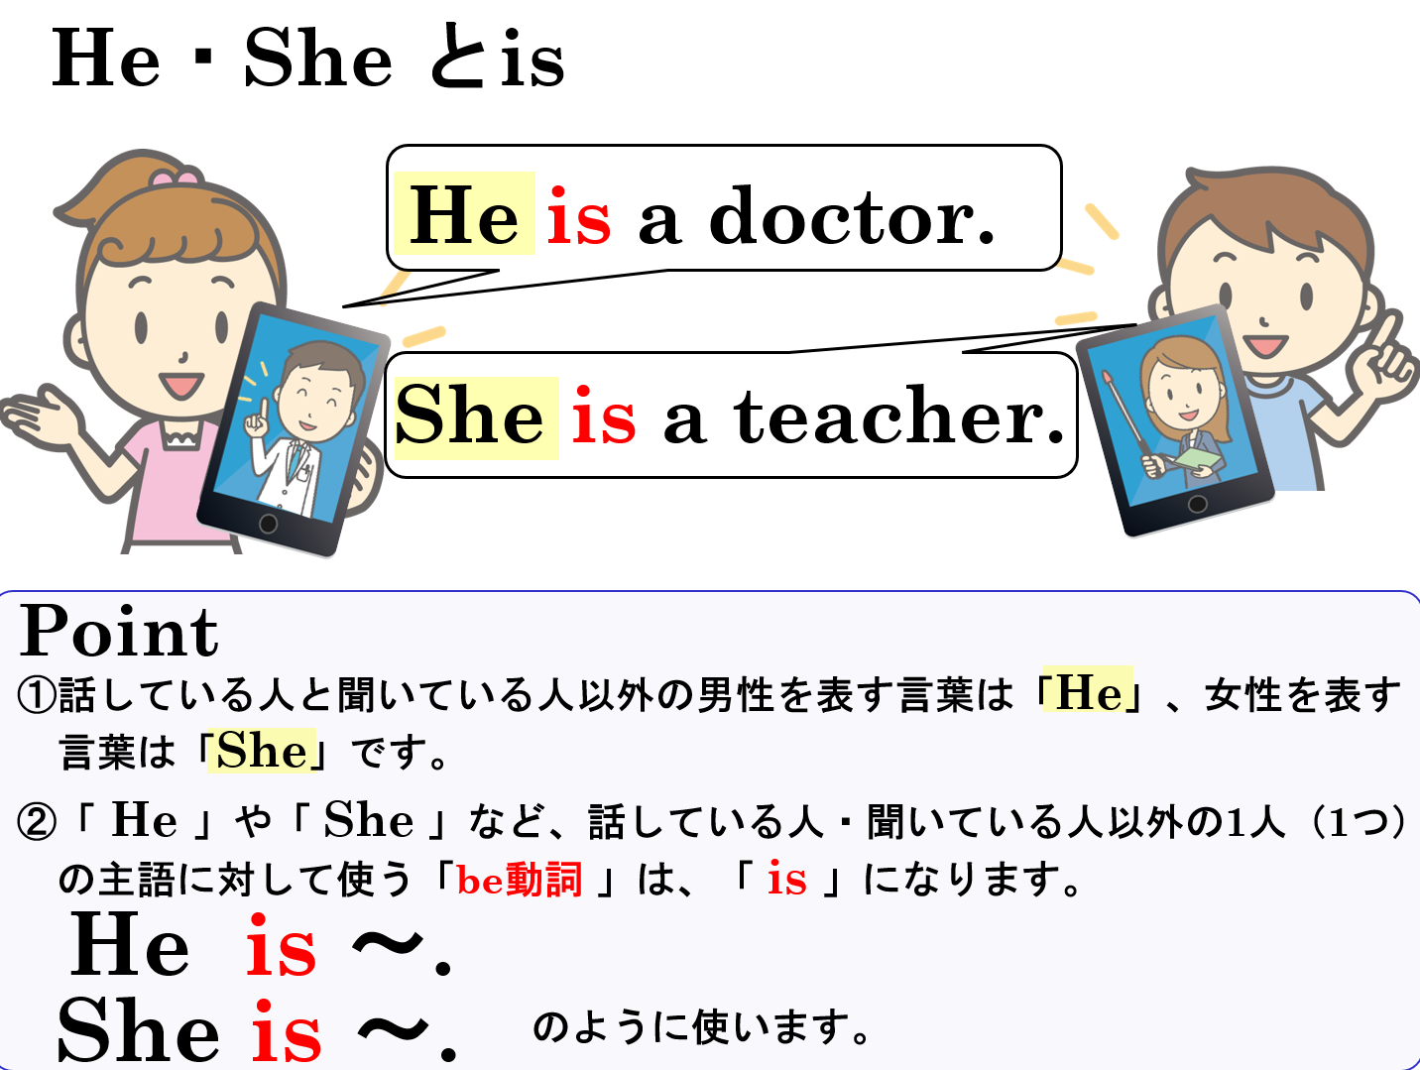

１．次の文の( )内のam, are, isの内、正しいものを選びましょう。
(1) Kenta ( am / are / is ) on the soccer team.
(2) I ( am / are / is ) a junior high school student.
(3) My English teacher ( am / are / is ) a baseball fan.
(4) You ( am / are / is ) a good student.
(5) That girl ( am / are / is ) my classmate.
２．次の対話文の( )内のHe, Sheのいずれか適切なものを選びましょう。
(1) Ken : Look at that doctor. That is my mother.
Yuki: Wow! ( He / She ) is cool!
(2) Emi : This is my brother, Shun.
Kota: ( He / She ) is very tall.
３．正しい英文になるように、それぞれの( )に適切な英語を書き入れましょう。
(1) This is Maiko. ( She ) ( is ) a tennis player.
(2) This is Tom. ( He ) ( is ) busy today.
(3) This is Ms. Green. ( She ) ( is ) my homeroom teacher.
(4) That is Mr. Tanaka. ( He ) ( is ) your Japanese teacher.
４．日本語の意味を表すように英文を書きましょう。
(1) 彼は医者（a doctor）です。
(2) 彼女は私の姉（my sister）です。
(3) 彼は幸せ（happy）です。
(4) 彼女は疲れて（tired）います。

１．次の文の( )内のam, are, isの内、正しいものを選びましょう。
(1) He ( am / are / is ) on the soccer team.
(2) I ( am / are / is ) a junior high school student.
(3) My English teacher ( am / are / is ) a baseball fan.
(4) You ( am / are / is ) a good student.
(5) She ( am / are / is ) my classmate.
２．次の対話文の( )内のHe, Sheのいずれか適切なものを選びましょう。
(1) Ken : Look at that doctor. That is my mother.
Yuki: Wow! ( He / She ) is cool!
(2) Emi : This is my brother, Shun.
Kota: ( He / She ) is very tall.
３．正しい英文になるように、それぞれの( )に適切な英語を書き入れましょう。
(1) This is Maiko. ( She ) ( is ) a tennis player.
She is my sister.
(2) This is Tom. ( He ) ( is ) busy today.
(3) This is Ms. Green. ( She ) ( is ) my homeroom teacher.
(4) That is Mr. Tanaka. ( He ) ( is ) your Japanese teacher.
４．日本語の意味を表すように英文を書きましょう。
(1) 彼は医者（a doctor）です。
He is a doctor.
(2) 彼女は私の姉（my sister）です。
She is my sister.
(3) 彼は幸せ（happy）です。
He is happy.
(4) 彼女は疲れて（tired）います。
She is tired.

