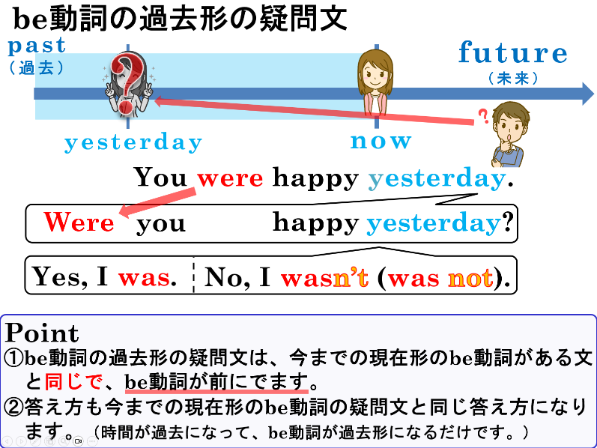
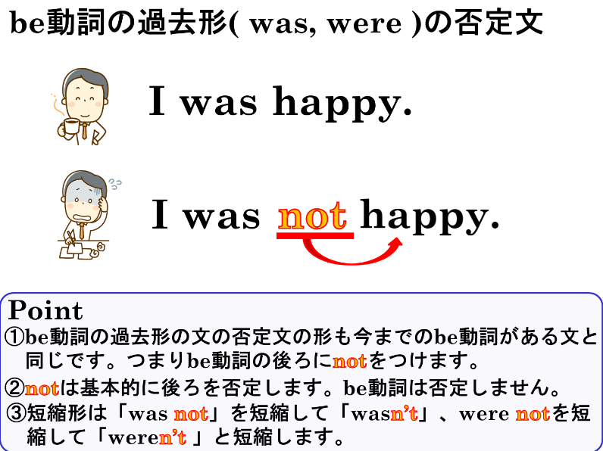

１．次の文をたずねる形（疑問文）にして書きましょう。また、（ ）内の答え方で書きましょう。
(1) You were sick yesterday.（yes）
(2) He was in America last week.（no）
(3) It was rainy yesterday.（yes）
(4) They were sad last night.（no）
２．次の文を否定文にして書き換えましょう。
(1) I was sad yesterday.
(2) She was angry this morning.
(3) We were happy yesterday.
３．答えに合うように、相手がたずねた疑問文を完成させましょう。
(1) A：( Were ) ( you ) tired after track practice?
B：Yes, I was.
(2) A：( Was ) ( it ) rainy yesterday?
B：No, it wasn’t.
(3) A：( Were ) ( they ) in Kyoto last week?
B：Yes, they were.
４．日本文の意味に合うように、( )内に適切なbe動詞の過去形を書き入れましょう。
(1) I ( wasn’t ) busy last Sunday. I ( was ) free.
昨日の日曜日、私は忙しくありませんでした。暇でした。
(2) They ( weren’t ) at home last night. They ( were ) in the park.
昨日の夜、彼らは家にいませんでした。公園にいました。
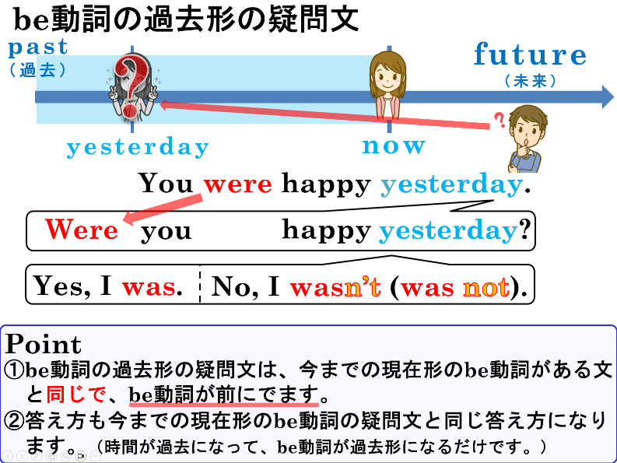

１．次の文をたずねる形（疑問文）にして書きましょう。また、（ ）内の答え方で書きましょう。
(1) You were sick yesterday.（yes）
Yes, I was.
Were you sick yesterday?
(2) He was in America last week.（no）
( No, he wasn’t. )

Was he in America last week?
No, he was not.

(3) It was rainy yesterday.（yes）
Yes, it was.
Was it rainy yesterday?
(4) They were sad last night.（no）
No, they were not.
Were they sad last night?
( No, they weren’t. )

２．次の文を否定文にして書き換えましょう。
(1) I was sad yesterday.
I was not (wasn’t) yesterday.
(2) She was angry this morning.
She was not (wasn’t) angry this morning.
(3) We were happy yesterday.
We were not (weren’t) happy yesterday.
３．答えに合うように、相手がたずねた疑問文を完成させましょう。
(1) A：( Were ) ( you ) tired after track practice?
B：Yes, I was.
(2) A：( Was ) ( it ) rainy yesterday?
B：No, it wasn’t.
(3) A：( Were ) ( they ) in Kyoto last week?
B：Yes, they were.
４．日本文の意味に合うように、( )内に適切なbe動詞の過去形を書き入れましょう。
(1) I ( wasn’t ) busy last Sunday. I ( was ) free.
昨日の日曜日、私は忙しくありませんでした。暇でした。
(2) They ( weren’t ) at home last night. They ( were ) in the park.
昨日の夜、彼らは家にいませんでした。公園にいました。

