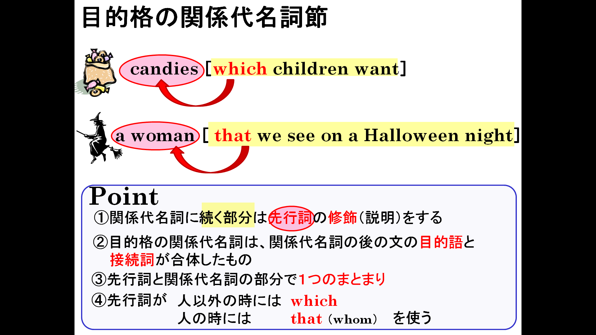

１．関係代名詞を使ってそれぞれの名詞を説明しよう。

(1) a cake + Emi made it

(2) a song + I like it the best

(3) a book + I bought the book last week

(4) a movie + we watched the movie yesterday

(5) a cellphone + Ken is using it

(6) a woman + Mike met her yesterday

(7) a girl + Tom called her yesterday

(8) some people + Sara knows them

(9) a man + Mari likes him

(10) some children + she takes care of them

