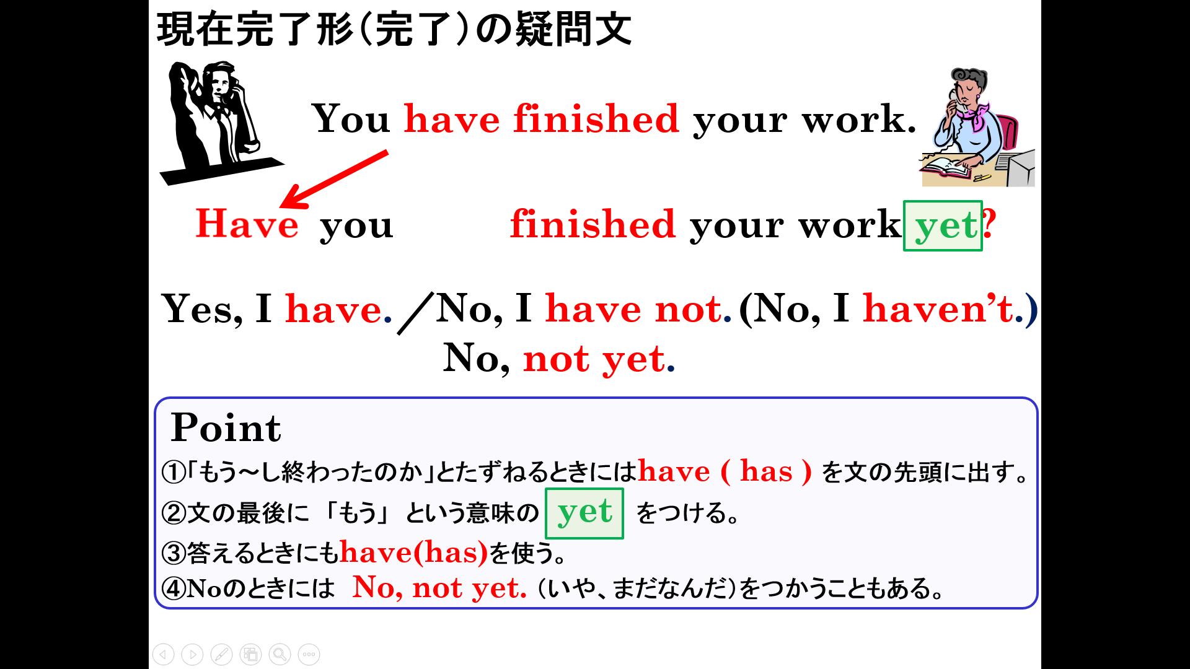

１．次の英文を「もう～してしまいましたか」という疑問文にし、（ ）内にあるYesかNoで答えよう
(1)You have already finished your homework. （Yes）
(2) You have already done your work. （No）
(3) Taro has already had breakfast.（Yes）
(4) Judy has already got my letter. （No）
(5) They have already finished the meeting. （Yes）
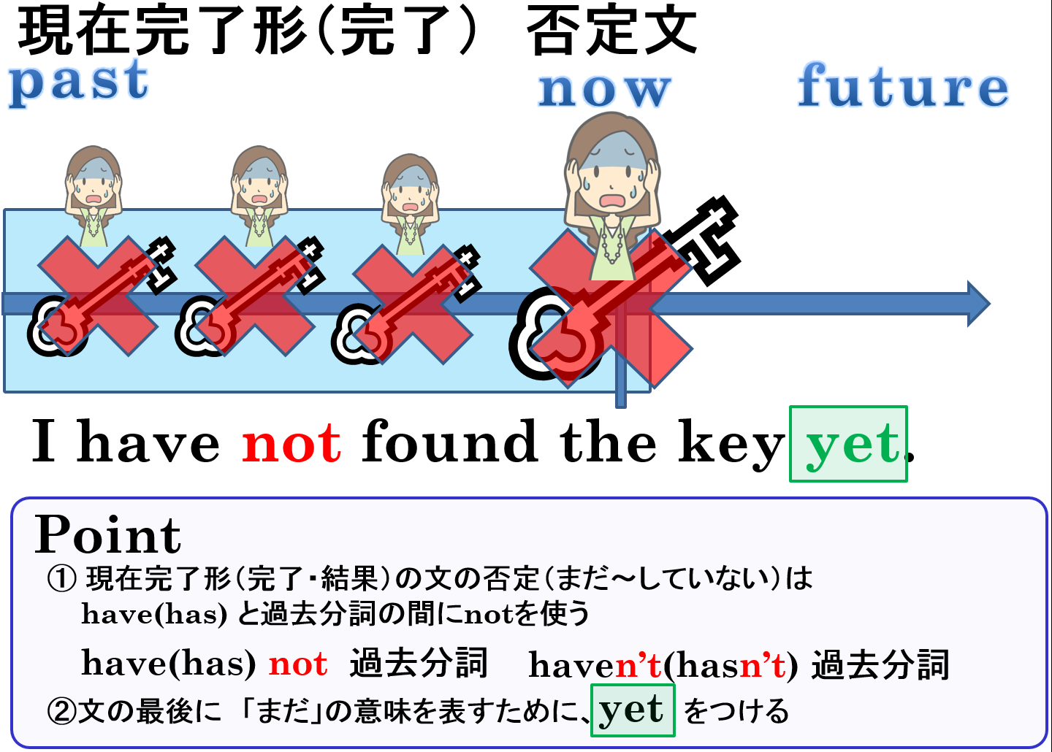

2．次の文を「まだ～していない」という否定文に書き換えよう。
(1) I have already done my work.
(2) You have already finished lunch.
(3) Paul has already cleaned his room.
(4) Mika has already done her homework.
(5) They have already found the key.

