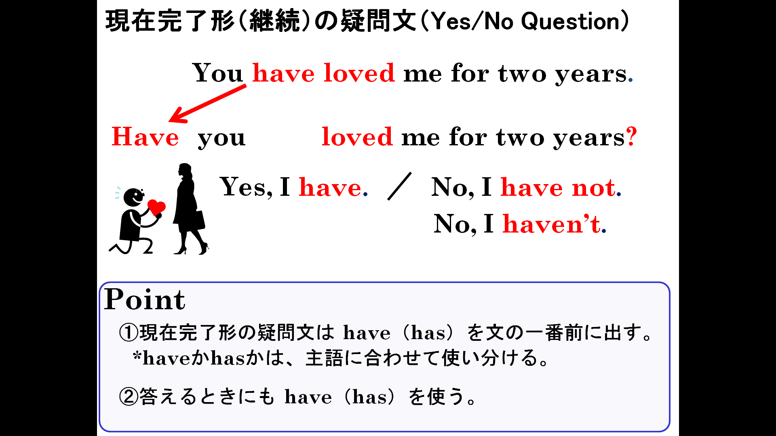

１．次の(1)～(5)の英文を疑問文に替え、（ ）内にあるYesかNoで答えるように書こう。
(1)You have lived in Japan for three years. （Yes）
(2) Alice has lived in Japan for three years. （No）
(3) Ken has played baseball for two years. （Yes）
(4) He has had that guitar since 2012. （No）
(5) They have studied English since 2013. （Yes）
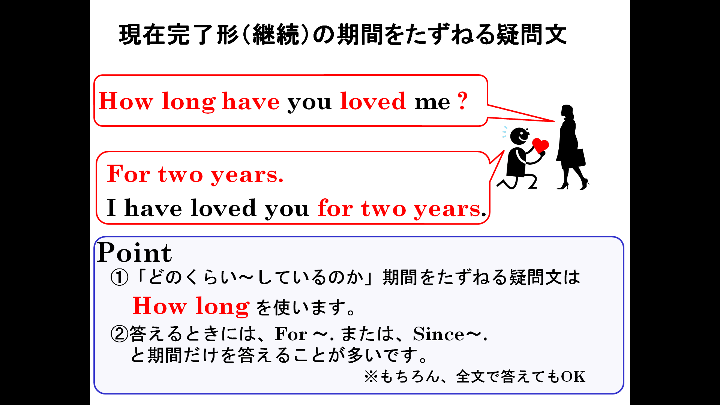

2．次の(1)～(5)の英文をどのくらいの期間しているのかたずねる英文にかえ、（ ）内の答えで答えよう。
(1)You have lived in Japan. （3年間）
(2) Alice has lived in Japan. （2年間）
(3) Ken has played baseball. （2年間）
(4) He has had that guitar. （2012年から）
(5) They have studied English. （2013年から）

