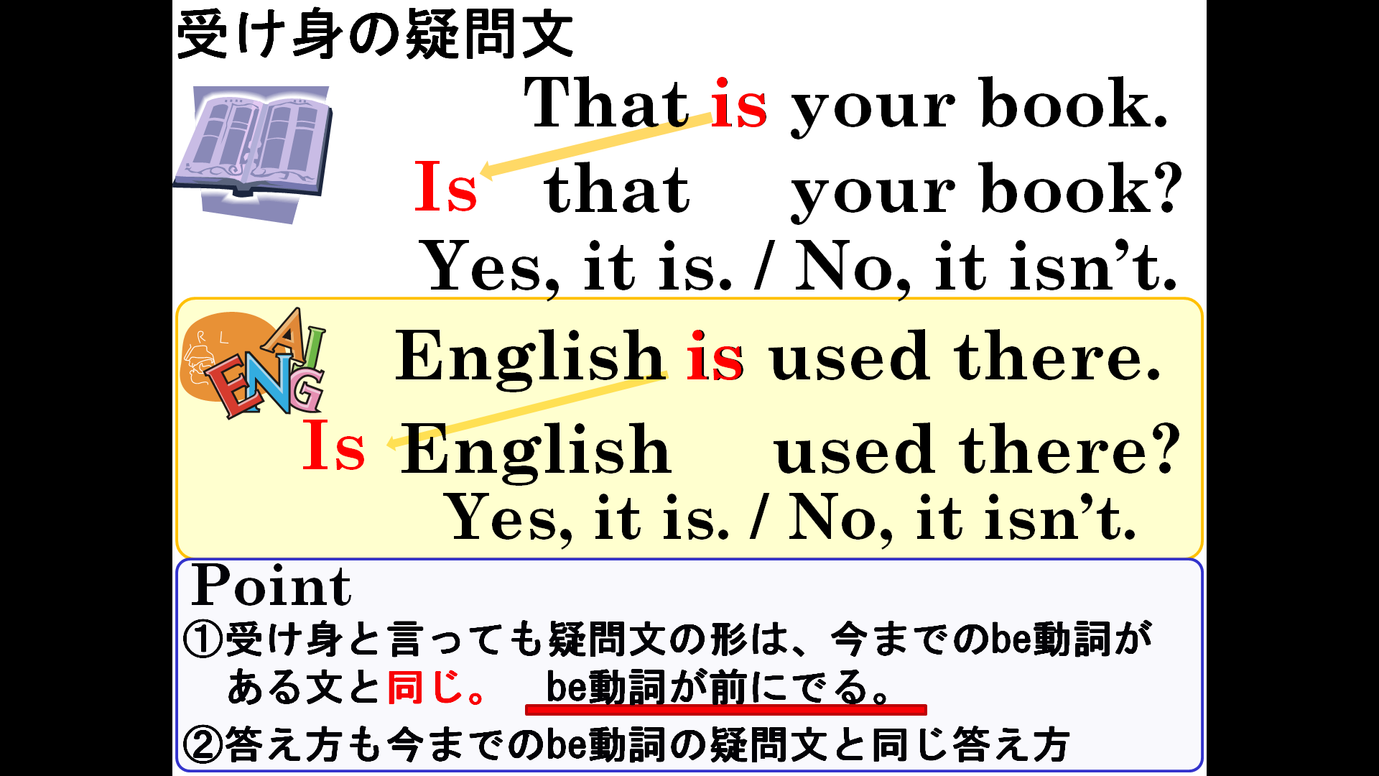

１．次の文の（ ）内で適切なものを選びなさい。
(1) ( Is / Are ) this room cleaned every day? - Yes, it ( is / are ).

(2) ( Is / Are ) these books read by young people? - No, they ( isn't / aren't ).

(3) ( Was / Were ) Ginkaku-ji built by Ashikaga Yoshimitsu?
- No, it ( wasn't / weren't ).
２．次の文を疑問文にして、（ ）内の指示で、その疑問文に答えなさい。
(1) Basketball is played by 10 players. （Yesで答える）

(2) This rabbit is seen at Kiyomizu-dera.（Noで答える）

(3) These car are made in Japan.（Noで答える）

(4) Many languages are spoken in India.（Yesで答える）

(5) 'Bocchan' was written by Soseki.（Yesで答える）

(6) These computers were used by students yesterday.（Noで答える）

３．次の疑問文を受け身の疑問文にしなさい。
（難しいです･･･疑問文を平叙文（普通の文）にかえてから、疑問文にするとよいでしょう）
(1) Do you see many stars in this town at night?

(2)Did Mr. Kasuga make this lunch last year?

