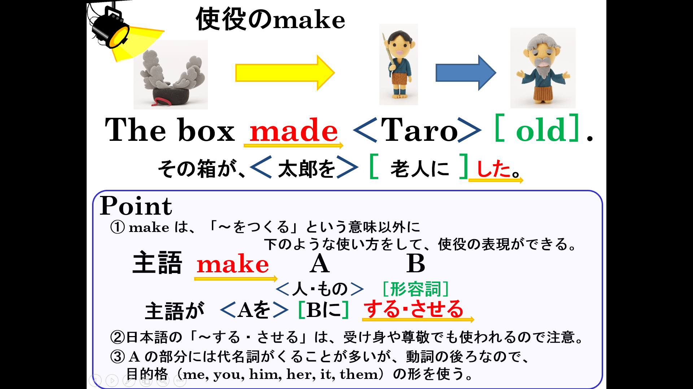

Think with your partner.
Fill in the blanks.
（１）≪ ≫made Issunboshi bigger.
（２）≪ ≫makes Doraemon happy.
（３）≪ ≫makes the world peaceful.
（４）Shizuka makes ＜ ＞ happy.
（５）Beans makes ＜ ＞ *weak. *弱い
（６）Love makes ＜ ＞ beautiful.
（７）Kibidango made Momotaro ［ ］.
（８）Love and courage make Ampanman［ ］.
（９）Water makes Ampanman ［ ］.

Free Talk about blanks with your partner. Before talking, fill in the blanks.
（１）≪ ≫made me happy.
≪ ≫makes me happy.
≪ ≫will make me happy.
（２）≪ ≫ made me sad.
≪ ≫ makes me sad.
≪ ≫ will make me sad.
（３）≪ ≫ made me *excited. *わくわくする
≪ ≫ makes me excited.
≪ ≫ will make me excited.

