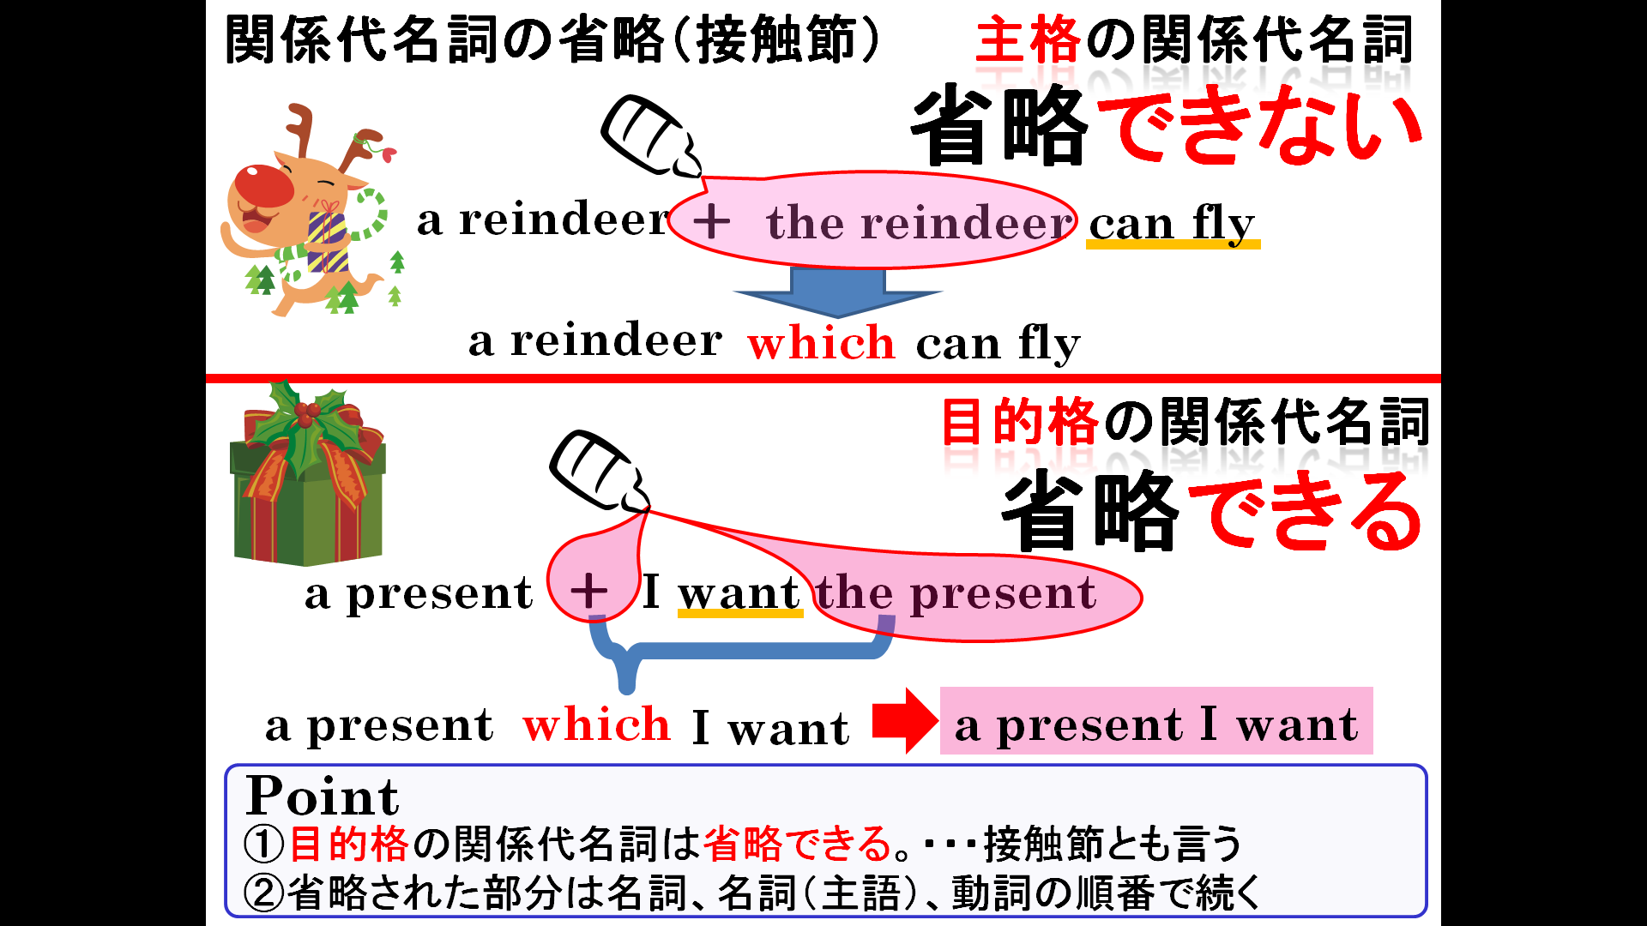

１．次の文の中で関係代名詞を省略できるものが6文あるので、その省略した文を書き、日本語に訳してみよう。
This is the dictionary which he uses every day.
Mr. Mori is a doctor who is very kind to old people.
Mike has lost the toy which his father bought for him.
He found the key which she lost last week.
They want a house that has five bedrooms.
Ms. Sato is a teacher who teaches us English.
Have you seen the book that I put on your desk?
The man that you saw at the store is Takuya's father.
This watch that he bought yesterday is very expensive.
Do you have a cat that is bigger than mine?

(1)訳（ ）

(2)訳（ ）

(3)訳（ ）

(4)訳（ ）

(5)訳（ ）

(6)訳（ ）

