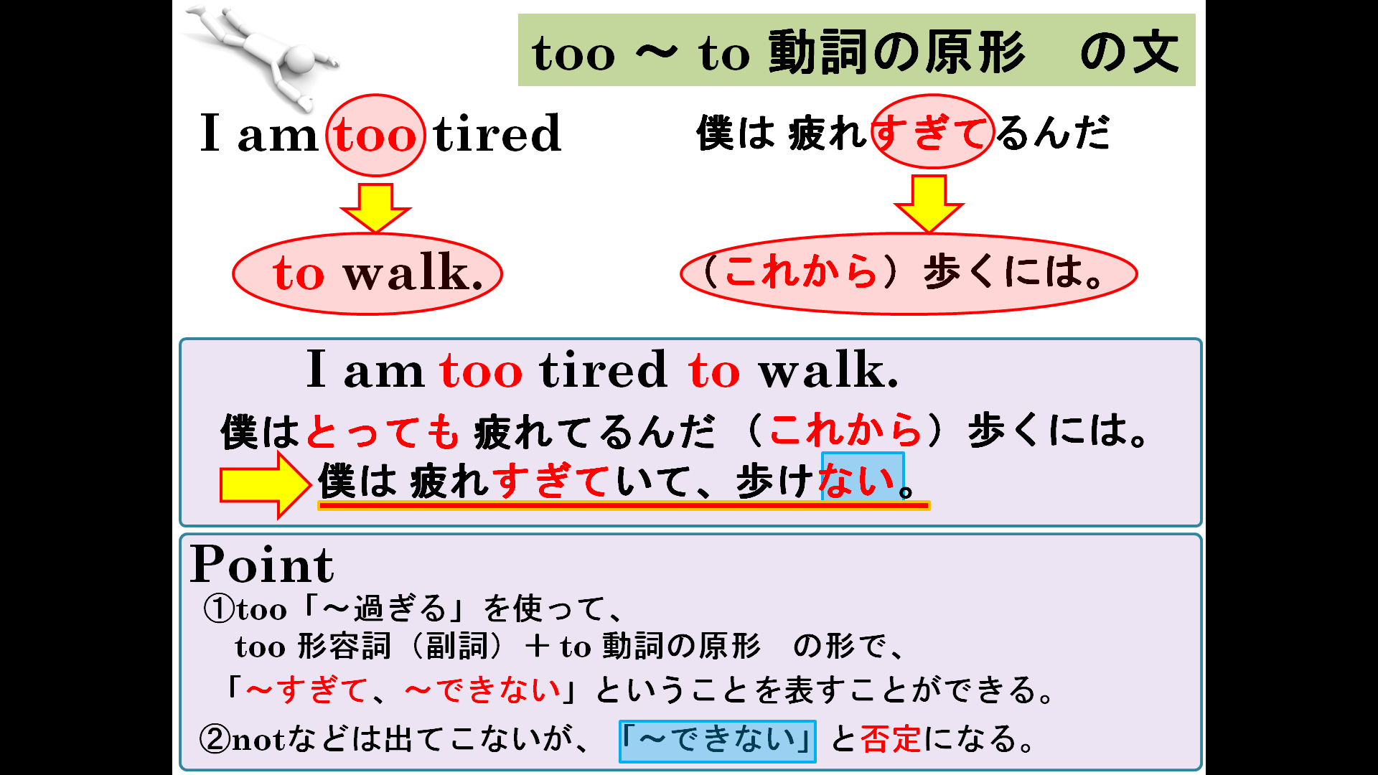
１．日本語の意味を表すように２つの文をまとめて1つの文にしよう。Make one sentence from two.
(1) I am busy. / I can't play video games. 私は忙しすぎてテレビゲームができない。

(2) Kumi is sleepy. / She can't study. 久美は眠すぎて勉強ができない。

(3) They are young. / They can't drive. 彼らは若すぎて運転ができない。

(4) This coffee is strong. / You can't drink. このコーヒーは濃すぎて飲めない。

(5) This curry is hot. / You can't eat. このカレーは辛すぎて食べられない。

(6) He ate too much. / He couldn't work. 彼は食べ過ぎて働けなかった。

２．どんな場面で言えばいいか考えて、覚えて使おう。Think the situation when you use these expressions.
(1) It's too late to do that.

(2) It's never too late to start.

(3) The news was too good to be true.

(4) It's too good for you to do that. （まだまだあまいな）

