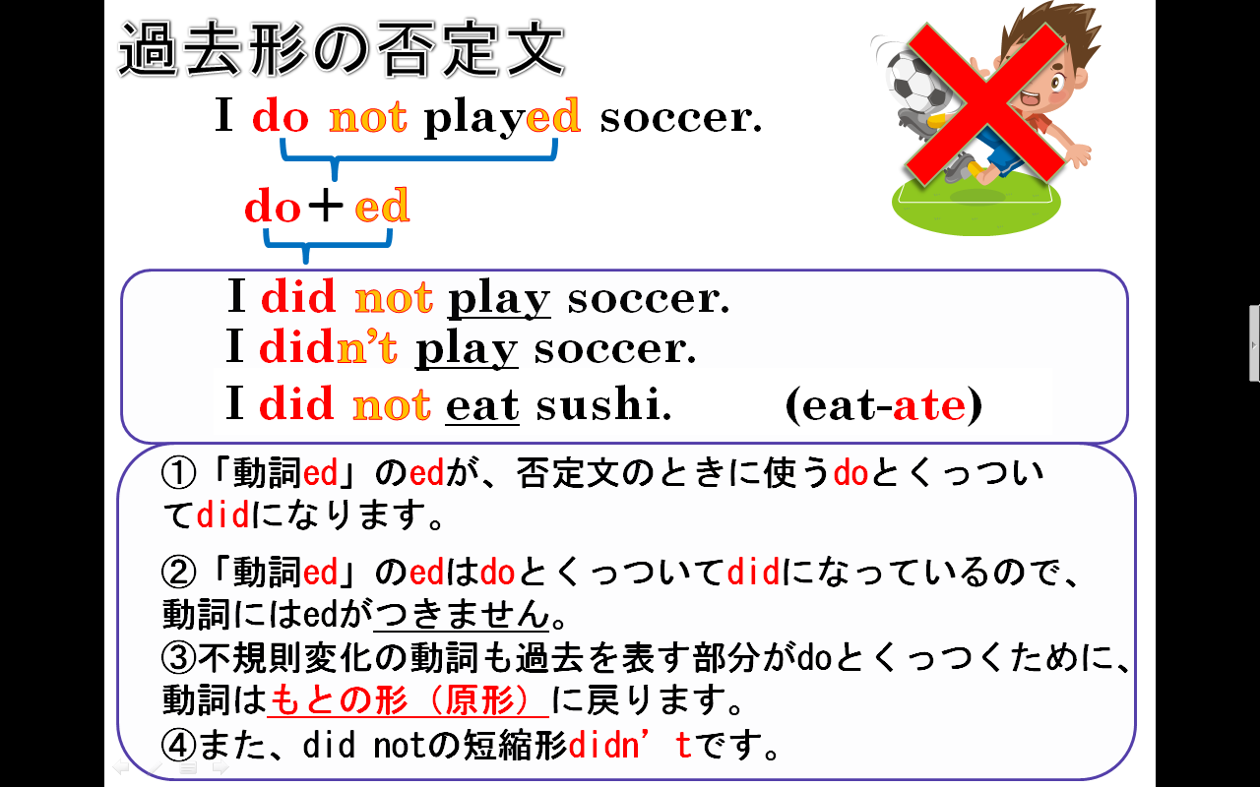
１．次の英文を「～しませんでした」という否定を表す表現に書き換えなさい。
(1) I played soccer yesterday.

(2) Tom watched TV last night.

(3) Yuki studied English last Sunday.

(4)Emi saw a movie last Sunday.

(5)She made lunch two days ago.

２．次の否定文「～しませんでした」を肯定文「しました」に書きさえなさい。
(1) I didn't study math yesterday.

(2) Taro didn't go to Kyoto last week.

(3) Yuko didn't buy a comic book yesterday.

