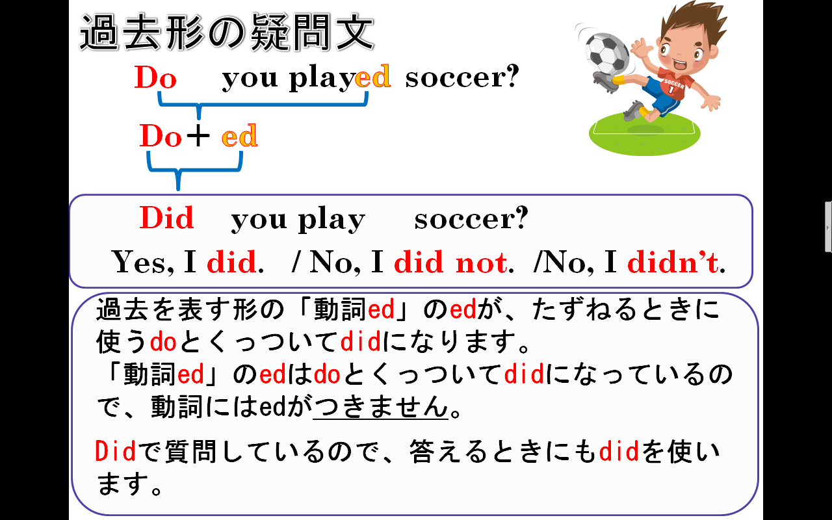
１．次の文を疑問文（たずねる文）にしなさい。(Change sentences to interrogative sentences)
(1) You watched TV yesterday.

(2) He played soccer last Sunday.

(3)She helped her mother last night.

(4) They studied science yesterday.

２．次の文を疑問文に答えなさい。(Answer the sentences)
(1) Did you study English yesterday? （Yesで答える）

(2) Did she use a computer yesterday? （Noで答える）

(3) Did Kumi play the piano last Monday? （Yesで答える）

(4) Did Ken live in Okinawa two years ago? （Noで答える）

