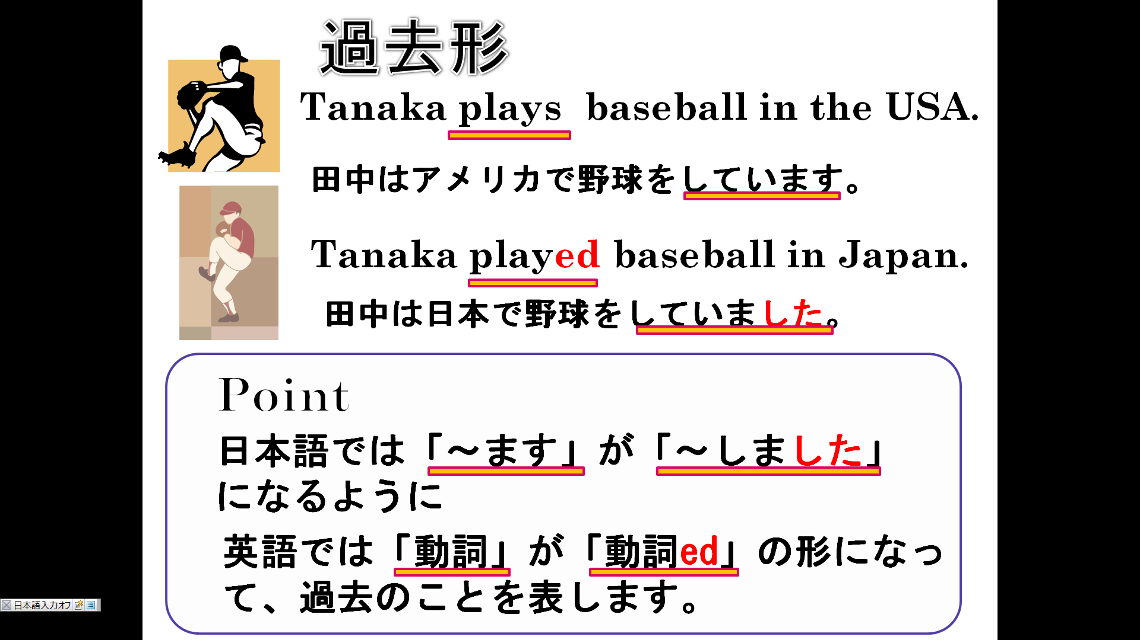
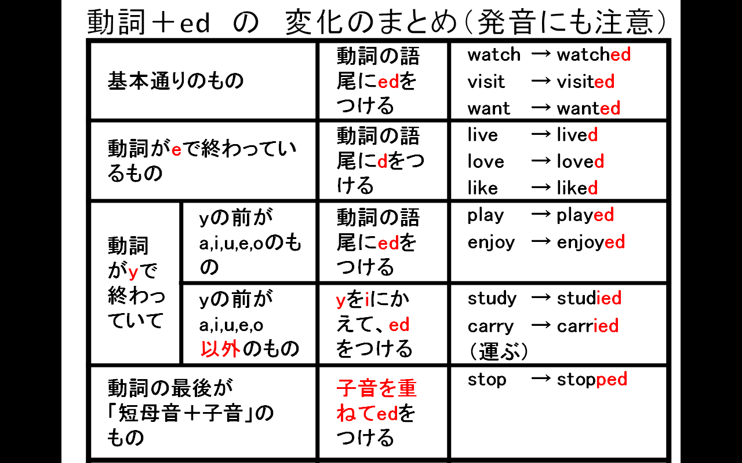
１．次の動詞を過去形にしなさい(Change verbs to past form)
(1)play |  |  | (6)use
(2)watch |  |  | (7)love
(3)cook |  |  | (8)live
(4)help |  |  | (9)study
(5)want |  |  | (10)stop
２．次の文の（ ）内の語を正しい形に直して過去の文に変えなさい。(Change ( verbs ) to past form)
(1) I （watch） TV yesterday.

(2) He （play）soccer last Sunday.

(3)They （study）English last night.

(4)She （walk）to school this morning.

