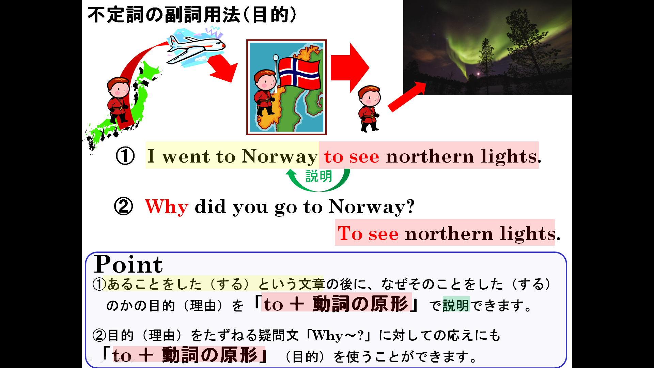

１．AとＢを意味がつながるように組み合わせて5つ文を書き、意味も書いてみよう。
to see her sister
to relax
to pass the exam
to buy some milk
to walk his dog
to be strong
to teach English
to play soccer
to practice tennis
to exchange e-mail

Mary went to the supermarket.
Ken went to the park.
Tom gets up early.
Mr Smith came to Japan.
Ellen will visit France.
Mark uses a computer.
Mrs Brown bought a racket.
Yuko studies hard.
Jiro eats a lot.
Nancy listens to music.

(1)訳（ ）
(2)訳（ ）
(3)訳（ ）
(4)訳（ ）
(5)訳（ ）
２．1で使わなかったものをつかって、Aにある文をWhy～?の疑問文にして、Bにあるもので応えよう。
(例) Why did Koichi go to a library? - To read books.
(1)

(2)

(3)

(4)

(5)
to teach English
to play soccer
to walk his dog
to be strong
to see her sister
to practice tennis
to pass the exam
to relax
to buy some milk
to exchange e-mail
to see Kinkakuji
to fish
to eat hamburgers
to practice judo
to read books
Mr Smith came to Japan
Ken went to the park
Tom gets up early
Jiro eats a lot
Ellen will visit France
Mrs Brown bought a racket
Yuko studies hard
Nancy listens to music
Mary went to the supermarket
Mark uses a computer
Takeshi visited Kyoto
Shinji went to the river
Ema goes to a fast‐food restaurant
Naomi goes to a judo school
Koichi went to a library

