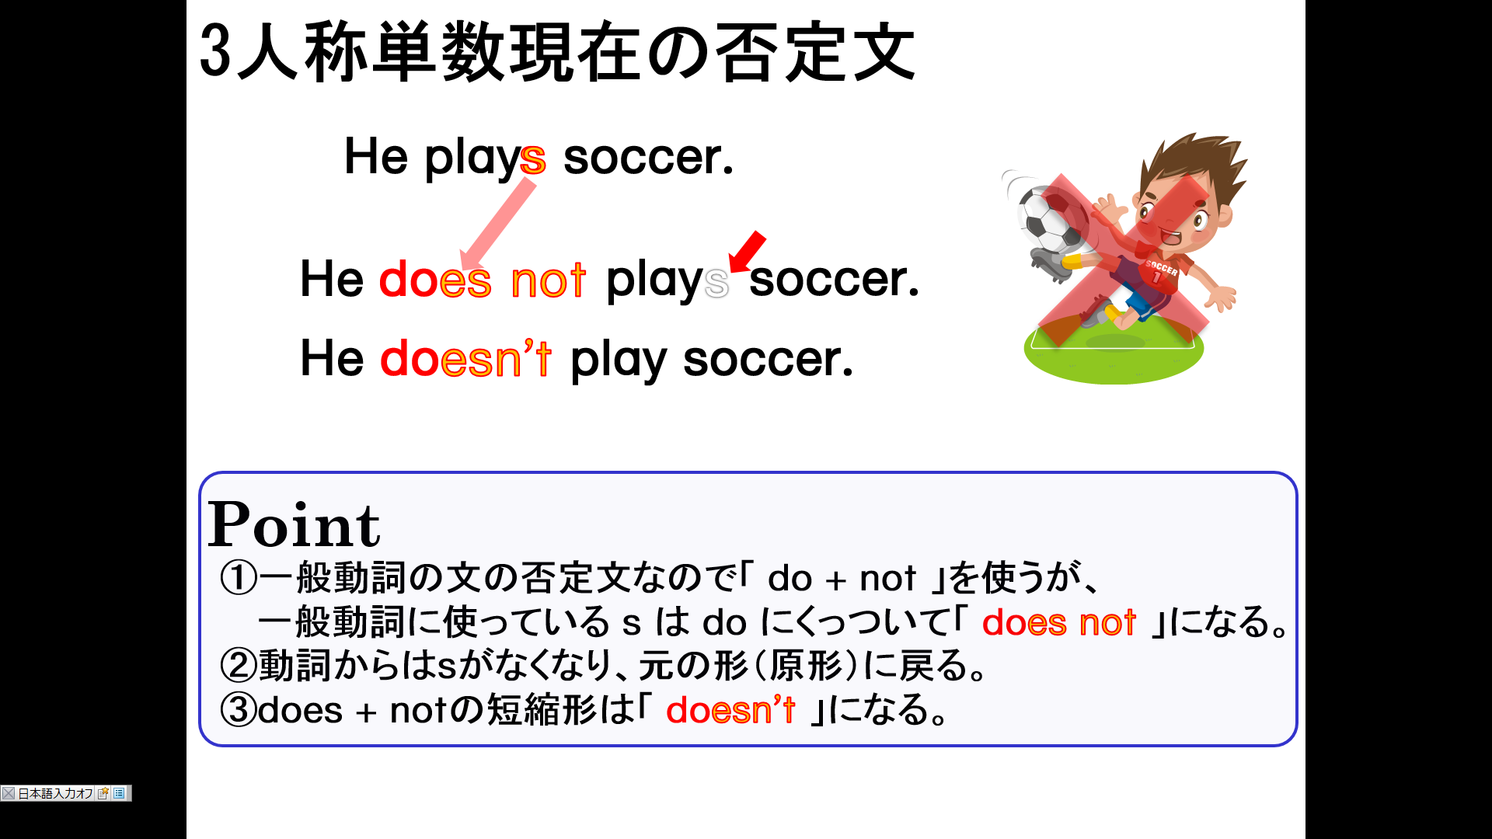
１．次の英文を「～しません。」という否定を表す表現に書き換えなさい。
(1) Taro plays basketball.

(2) Mika likes softball.

(3) He plays the piano.

(4) She gets up at seven.

(5) He eats breakfast at six.

(6) Takashi leaves home at seven.

(7) Ken’s mother watches TV before dinner.

(8) He does his homework.

(9) My father takes a bath after dinner.

(10) My sister goes to bed at eleven.

