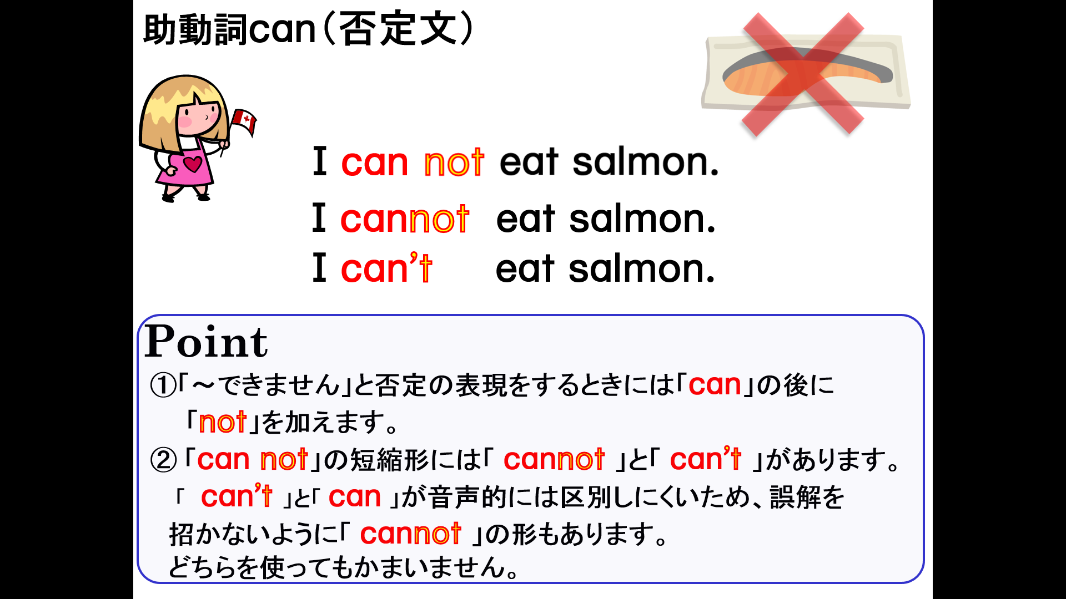
１．次の英文を「～できません。」という否定を表す表現に書き換えなさい。
(1) I can play soccer.

(2) You can play baseball.

(3) Yuki can dance well.

(4) She can ski well.

(5) Tom can run fast.

(6) He can play kendama well.

(7) They can swim fast.

(8) We can drive a car.

