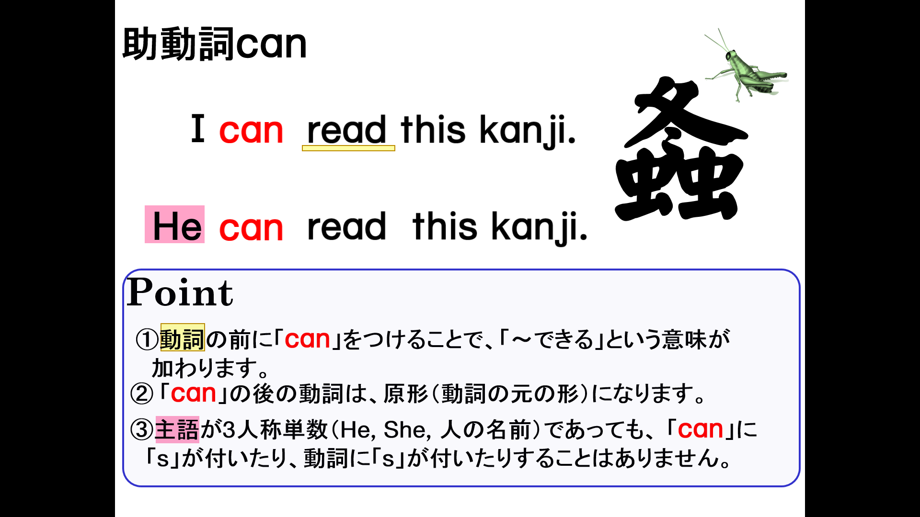
１．次の英文を「～できる」という表現に書き換えなさい。
(1) I play soccer.

(2) You play baseball.

(3) Yuki plays volleyball.

(4) You snowboard.

(5) Ken plays basketball.

(6) He swims.

(7) Emma dances.

(8) She plays table tennis.

(9) They play the piano.

(10) Tom and Judy eat natto.

